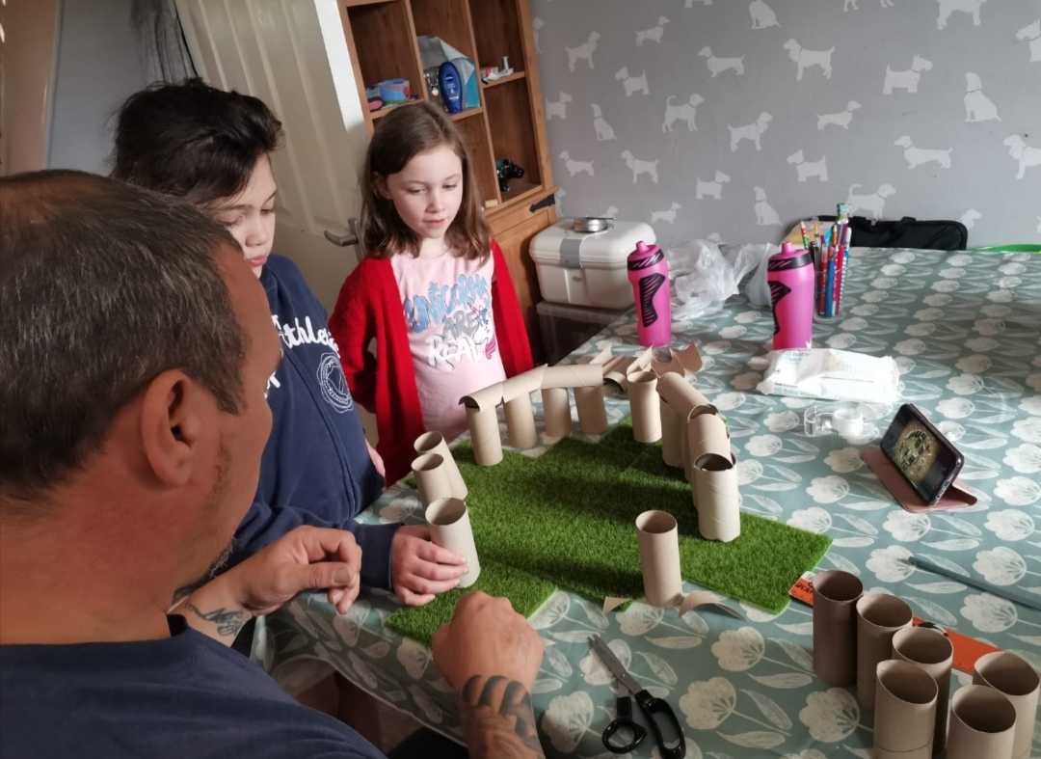
D.T Project
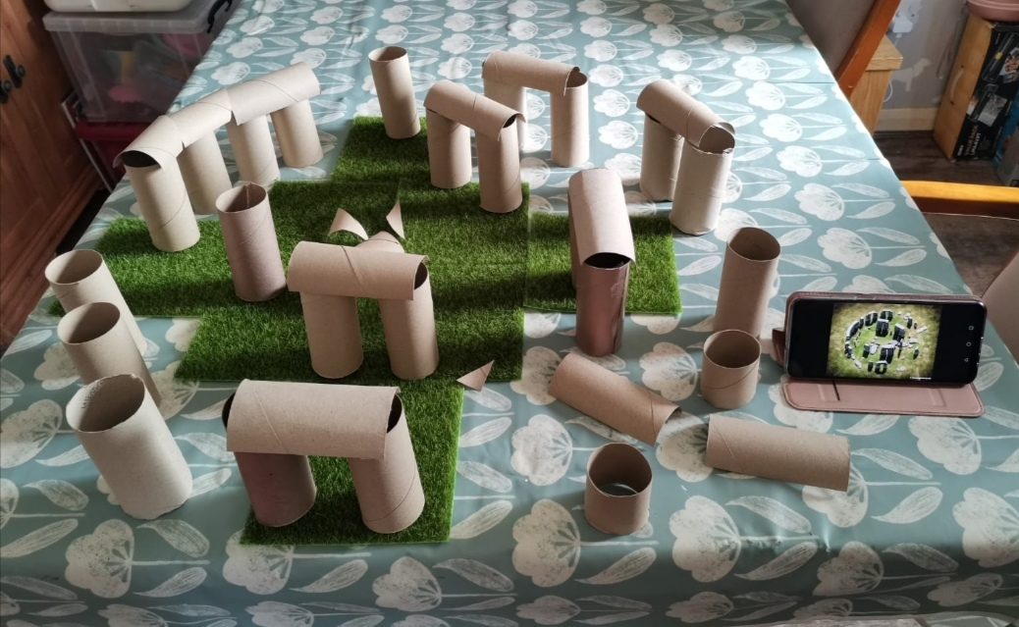
Frankie and Ava recreate Stonehenge using toilet rolls.
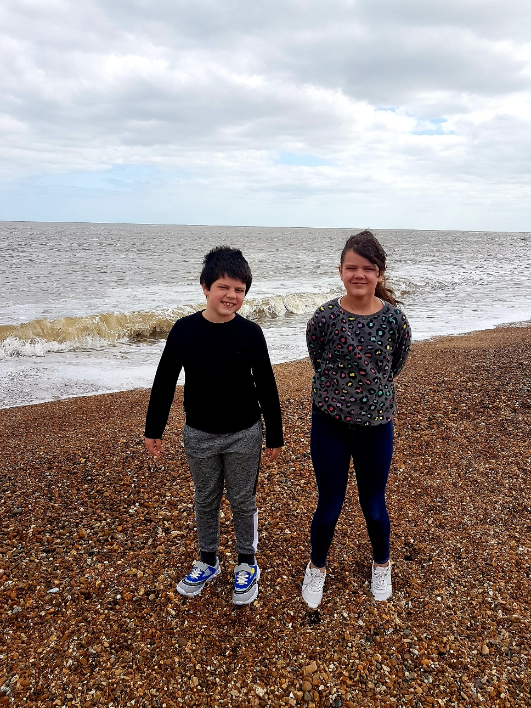
Enjoying the Suffolk Coast
Harry and Megan enjoy a walk on the beach.
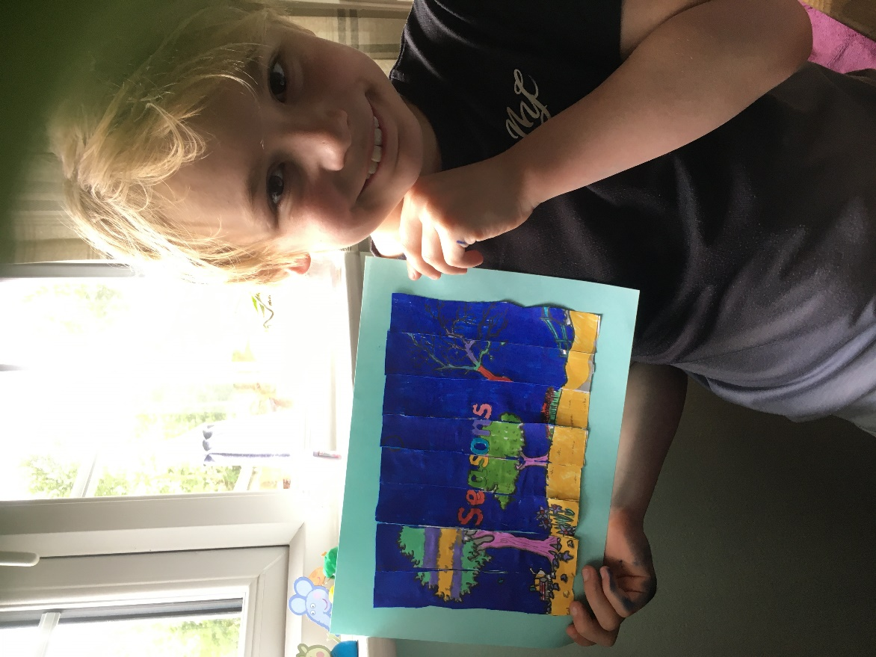
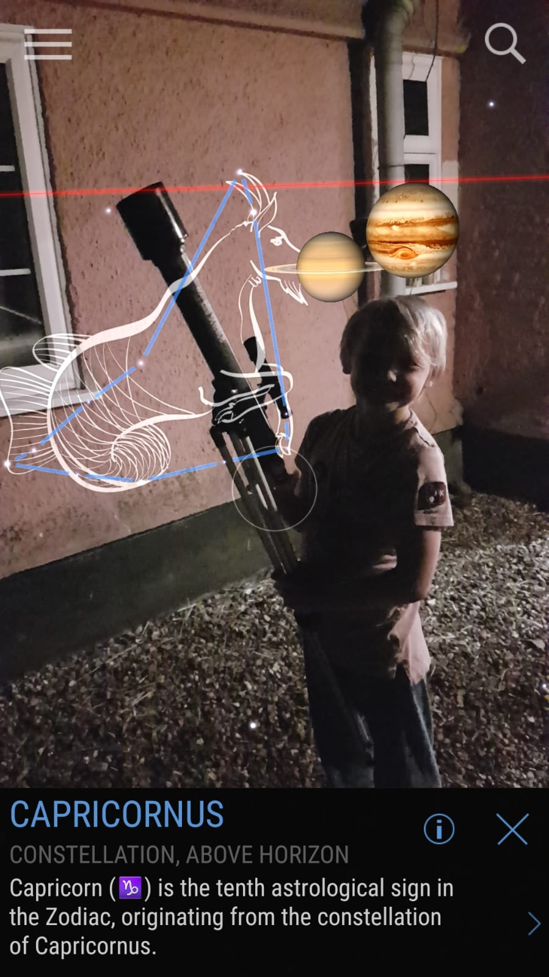
Liam has researched his star sign Capricorn and very cleverly superimposed the image and planets onto a photo of himself with a telescope.
Liam has created an agamograph (2 pictures depending on which way they are viewed)
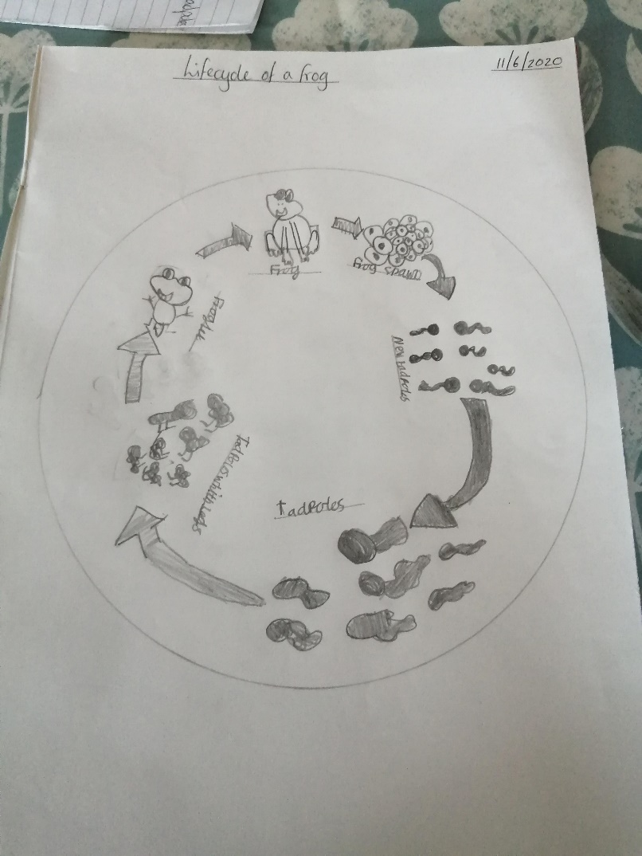
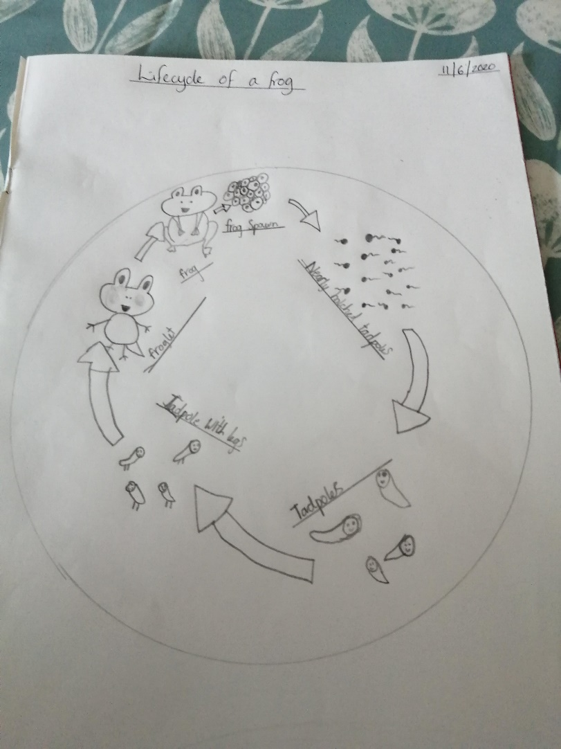
Frankie and Ava have been learning about the lifecycle of frogs.
Calming Jars.
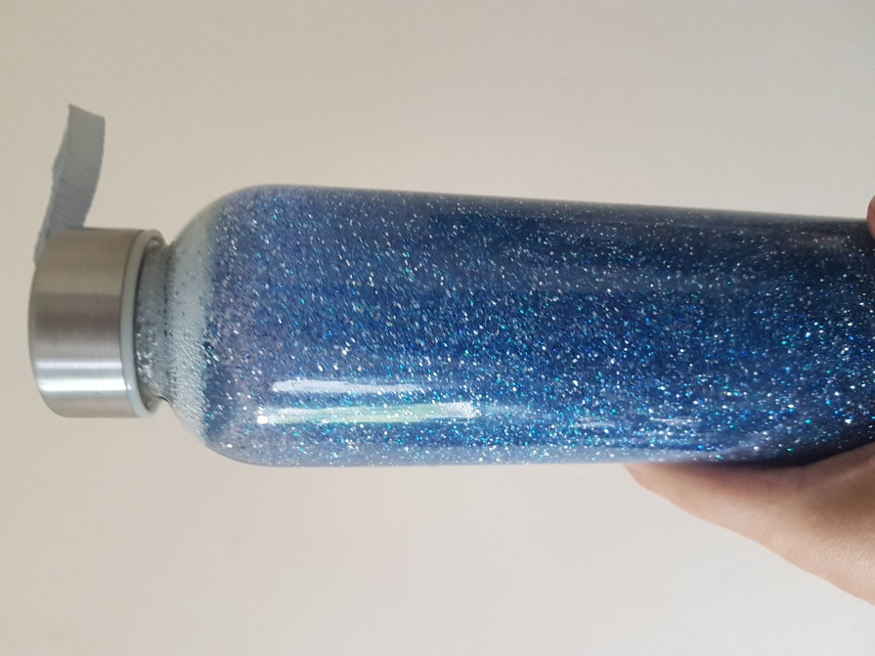
Harry has made a calming jar by adding some glitter glue, glitter shapes and a few drops of food colouring to a jar of water. Tightly screw on the lid so it is waterproof, give it shake and watch your worries disappear!

