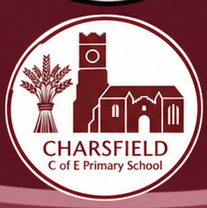
CHARSFIELD CHURCH OF ENGLAND PRIMARY SCHOOL
A WORLD OF
POSSIBILITIES
Personal Development, Cultural Capital
& Wider Experiences
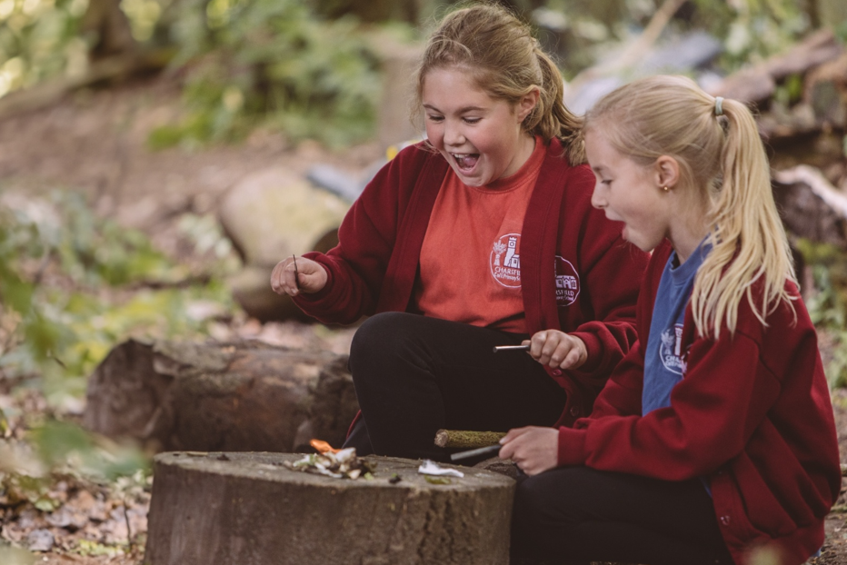
Our entitlement • Our experiences • Our progression

From first discoveries in Reception to confident, thoughtful and independent children in Year 6.
OUR COMMITMENT
Every child. Every opportunity.
Charsfield is a small rural primary school rooted in its village community. The surrounding Suffolk landscape provides extraordinary opportunities for belonging, learning and adventure. We also recognise that travel, cost, accessibility and family circumstances can limit access to experiences beyond the familiar.
Our entitlement is deliberately ambitious and inclusive: every child should encounter stories and live performance, heritage and different beliefs, the natural world and science, sporting challenge, community responsibility and opportunities to create and lead.

What makes our approach distinctive
BELONG | DISCOVER | GROW
Value village life, family cultures, traditions and our school community. | Explore unfamiliar places, people, ideas and experiences beyond our immediate locality. | Develop curiosity, vocabulary, confidence, empathy, independence and the capacity to contribute.

Six connected strands
01 Culture, literature and performance
02 Heritage, faith and a sense of time
03 Place, nature, science and the wider world
04 Adventure, sport and physical confidence
05 Community, citizenship and responsibility
06 Creativity, STEM, enterprise and problem-solving
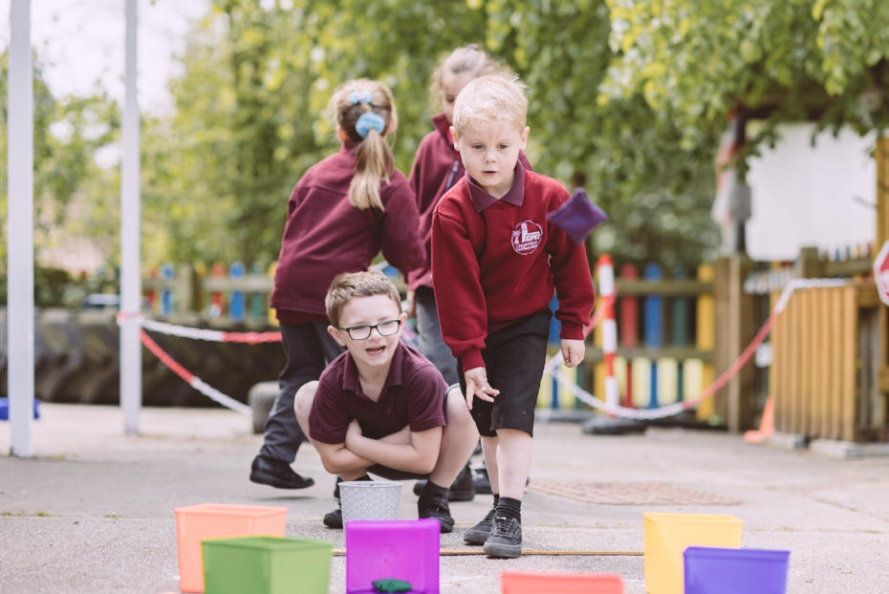

THE PROGRESSION STORY
From encounter to leadership
Experiences may be revisited; the expectation of children’s thinking, participation and independence grows.
RECEPTION | YEARS 1–2 | YEARS 3–4 | YEARS 5–6
NOTICE & JOIN IN  Explore safely, name feelings, take part with modelling and express first responses. | DESCRIBE & CONTRIBUTE  Ask questions, retell, compare, cooperate and begin to make choices. | INVESTIGATE & COLLABORATE  Explain connections, rehearse, solve problems and take shared responsibility. | EVALUATE & LEAD  Justify views, respond to feedback, manage challenge and support younger pupils.

The development we want to see
Personal development | Early development | Greater independence by Year 6
Communication & confidence | Listen, name, retell and speak with support | Present, debate, evaluate and adapt communication to an audience
Cultural understanding | Notice different stories, celebrations and ways of life | Compare perspectives respectfully and make thoughtful connections
Independence & resilience | Follow routines and try safe new experiences | Plan, persevere, assess risk and manage unfamiliar situations
Relationships & belonging | Join in, share, take turns and feel included | Collaborate, mentor, show empathy and take leadership
Citizenship & responsibility | Help with simple tasks and know who keeps us safe | Understand public services and take meaningful action
Curiosity & problem-solving | Explore, ask why and experiment | Investigate, use evidence, improve designs and reflect

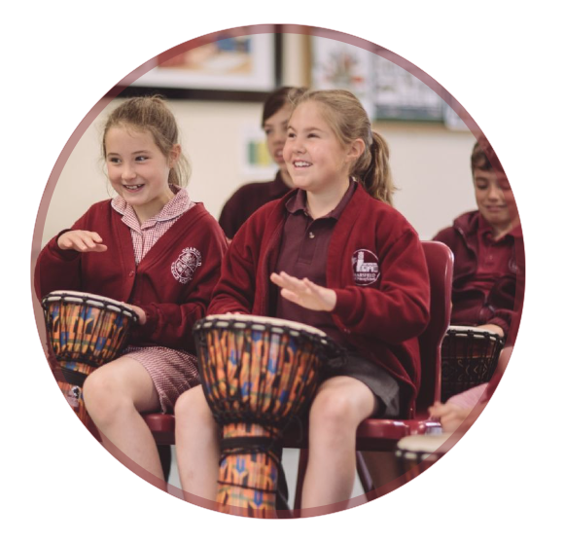
THE LIVED CURRICULUM
Our experiences across the year
The following map integrates the additional termly draft with the wider entitlement inventory. It is an experience schedule, not a promise that each item takes place every year; staffing, availability, cost and pupils’ needs will shape final planning.

Autumn term
Reception and KS1 | KS2
The Gruffalo Granny live book launch; Little City; pantomime; church (Harvest/Nativity); Forest Schools; Charsfield village walk linked to homes. | Hedingham Castle; church (Harvest/Nativity); Crucial Crew; SPARKS Fire Service; PCSO; owl sanctuary science investigation; Thomas Mills The Wizard of Oz; weekly swimming; PE Shed; basketball workshop.

Spring term
Reception and KS1 | KS2
Mini Monsters science visit; Easton Farm Park; SPARKS Fire Service (Great Fire of London); Lorraine’s multicultural dance workshop; tractor and farmer visit; Forest Schools; Little City; potato growing and cooking. | Mini Monsters; Jimmy’s Farm (“Sow, Grow”); SPARKS Fire Service water safety; Lorraine’s Anglo-Saxon/Tudor folk-dancing workshop; weekly swimming; PE Shed; tractor and farmer visit; Snape Maltings music celebration.

Summer term
Reception and KS1 | KS2
Kentwell Hall; Miraiker puppet workshop; summer picnic; Forest Schools; Sports Day; Little City; potato growing and cooking. | Kentwell Hall; mobile planetarium; Miraiker puppet workshop; weekly swimming; PE Shed; Sports Day.

Across the year: parental share events, World Book Day, Wilder Schools, film evening and Christmas Fayre.
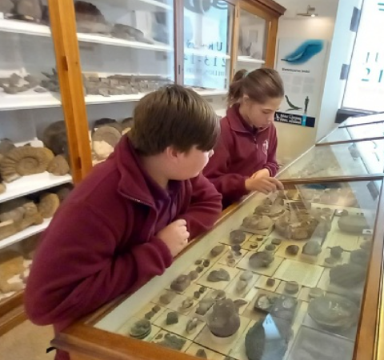
STRAND 01
Culture, literature & performance
Children encounter professional and community arts, become confident storytellers and performers, and learn to interpret meaning and respond to different artistic forms.
Phase | Progression in children’s learning | Experiences and visits
Reception | Enjoy stories, listen and respond; name characters and feelings; join simple performances. | Gruffalo Granny book launch; travelling theatre; puppetry; Little City; shared reading.
Years 1–2 | Retell and perform more clearly; speak audibly; describe a response to live performance. | Pantomime; visiting authors/illustrators; book launches; Miraiker puppetry; World Book Day.
Years 3–4 | Rehearse together, explore different art forms and describe how performance communicates. | Thomas Mills Wizard of Oz; multicultural dance; Snape Maltings music opportunities.
Years 5–6 | Perform with greater independence, evaluate artistic choices and take responsibility for group outcomes. | School musical performances; Snape Maltings; summer/Christmas shows; mentoring younger readers.

Look for impact
Children who listen attentively, express themselves, take part meaningfully and become increasingly confident performers and audiences.
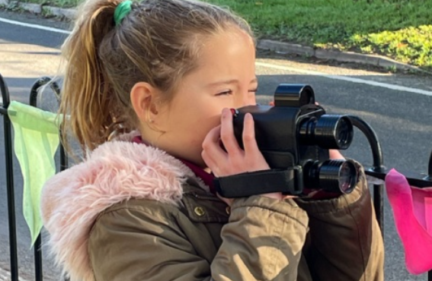
STRAND 02
Heritage, faith & a sense of time
Authentic places and encounters develop historical enquiry, identity, respect for beliefs and the confidence to compare different perspectives.
Phase | Progression in children’s learning | Experiences and visits
Reception | Recognise familiar celebrations and places; notice the difference between now and long ago. | Church Harvest/Nativity; village walk; initial encounters with historic buildings.
Years 1–2 | Use objects and stories to compare then and now; ask simple questions about the past. | Kentwell Hall; Great Fire of London / Fire Service link; church visits.
Years 3–4 | Use evidence at historical sites and make links to studied periods and cultures. | Hedingham Castle; Kentwell Tudor experiences; Time and Tide Museum; multicultural folk dance.
Years 5–6 | Consider different perspectives, interpret evidence and discuss beliefs and change respectfully. | Debach Bomb Group WWII visit; Kentwell Hall; church visits and other curriculum-linked heritage experiences.

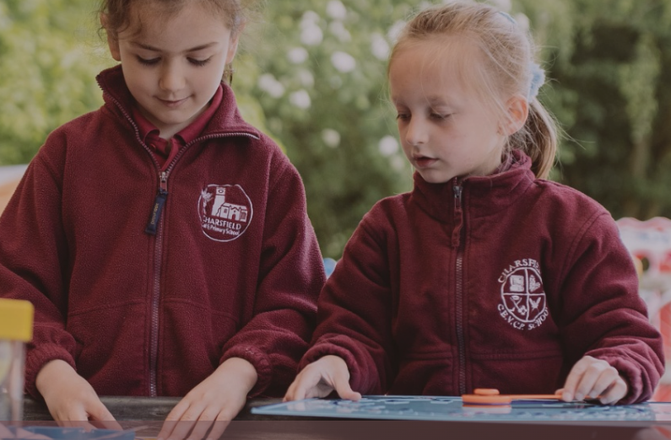
STRAND 03
Place, nature, science & the wider world
We begin with local observation and develop children’s scientific curiosity, geographical understanding, environmental care and awareness of wider places.
Phase | Progression in children’s learning | Experiences and visits
Reception | Notice seasons, living things and everyday features; explore outdoors safely. | Village walks; Forest Schools; mini-monsters; Easton Farm Park.
Years 1–2 | Describe, group and compare habitats and places; ask questions and record simple findings. | Easton Farm Park; tractor and farmer; growing potatoes; Wilder Schools.
Years 3–4 | Investigate habitats, processes and local land use; explain observations with evidence. | Jimmy’s Farm; owl sanctuary investigation; Mini Monsters; local fieldwork.
Years 5–6 | Connect ecosystems, sustainability, space and human activity; communicate reasoned conclusions. | Mobile planetarium; owl pellet investigation; Wilder Schools; more advanced fieldwork.

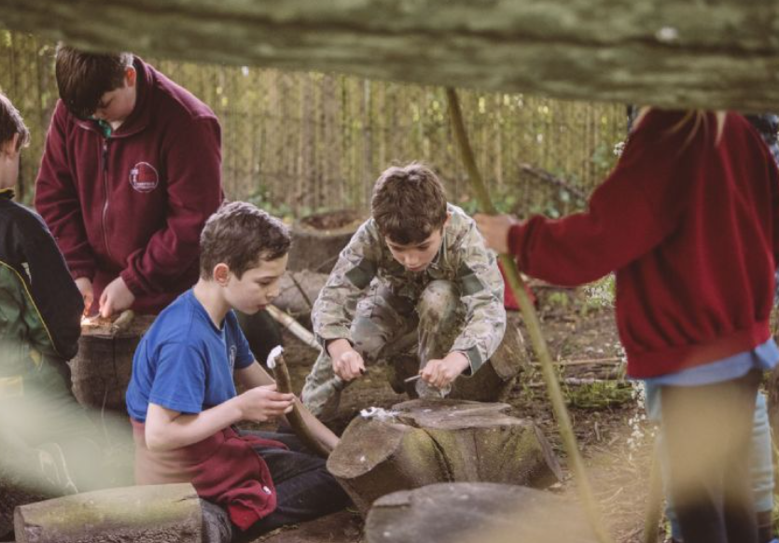
STRAND 04
Adventure, sport & physical confidence
Physical literacy and adventure enable children to enjoy challenge, develop teamwork and learn to take increasing responsibility for themselves and others.
Phase | Progression in children’s learning | Experiences and visits
Reception | Move confidently, follow simple safety routines and enjoy trying new challenges. | Forest Schools; Sports Day; dance; introductory movement and games.
Years 1–2 | Build coordination, resilience and fair play; manage equipment with support. | Forest Schools; sports events; dance and inclusive physical activities.
Years 3–4 | Apply skills with others, begin to manage challenge and develop swimming confidence. | Weekly swimming; PE Shed; basketball; sports competitions; cross-country.
Years 5–6 | Show leadership, water safety, independence and responsible risk-taking. | Weekly swimming; PE Shed; watersports; Hilltop residential (Year 6); sports competitions.

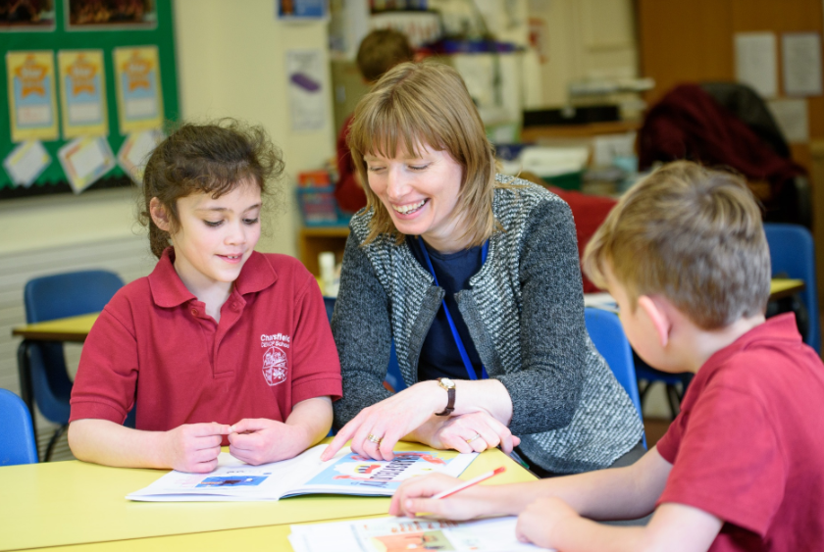
STRAND 05
Community, citizenship & responsibility
Children progress from belonging and helping to informed civic participation, leadership and making a positive difference.
Phase | Progression in children’s learning | Experiences and visits
Reception | Develop relationships, kindness, turn-taking and familiarity with people who help. | Family share events; Christmas Fayre; Fire Service visit; school celebrations.
Years 1–2 | Help in everyday routines; understand simple rules, safety and community roles. | Community celebrations; Fire Service; fundraising; Reading Café.
Years 3–4 | Explain ways to stay safe, contribute to school activities and show shared responsibility. | PCSO; eco-projects; Friends events; community fundraising.
Years 5–6 | Apply personal safety knowledge, take leadership and understand civic responsibility. | Crucial Crew; Bikeability (inventory); PCSO; charity initiatives and Green Flag Eco Award.

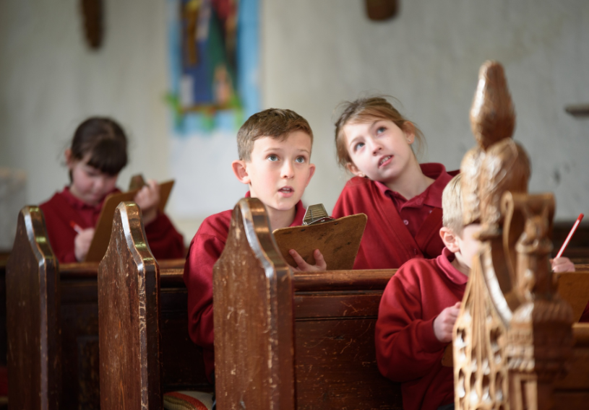
STRAND 06
Creativity, STEM & enterprise
Practical experiences foster imaginative thinking, mathematical curiosity and the confidence to design, test, evaluate and improve.
Phase | Progression in children’s learning | Experiences and visits
Reception | Play, make, grow, investigate and describe simple choices. | Little City; potato growing and cooking; construction; creative family events.
Years 1–2 | Try tools and materials, follow steps, test ideas and explain what worked. | Family STEM; illustrator workshops; Number Day; growing and cooking.
Years 3–4 | Work together to plan investigations, compare results and improve designs. | Jimmy’s Farm food chains; owl sanctuary life cycles; science and D&T activities.
Years 5–6 | Design and evaluate complex outcomes; use evidence, feedback and entrepreneurial thinking. | Owl pellet detective work; enterprise/fundraising; STEM challenges; family Maths Café.

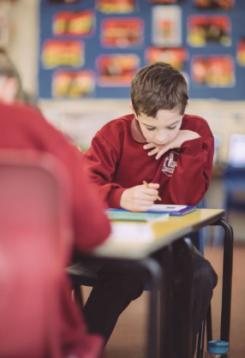
EQUITY BY DESIGN
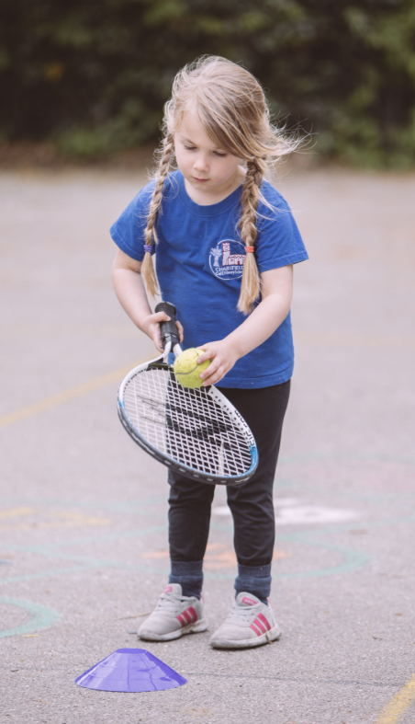
An entitlement for everyone
Our programme is part of the curriculum rather than an optional reward. We aim to remove barriers to participation so that children with SEND, children facing disadvantage and children who are anxious about unfamiliar experiences enjoy meaningful access.

Plan access from the outset
Choose appropriate venues, transport, timings, sensory environments and reasonable adjustments.

Prepare and communicate
Use visual schedules, social stories, practical previews and parent/carer conversations where useful.

Enable participation
Offer flexible roles, additional adult support, accessible physical pathways and alternative ways to express understanding.

Keep costs equitable
Minimise family costs and avoid making core opportunities contingent on optional contributions or clubs.

Review the difference made
Gather pupils’ voices, observe participation and confidence, and consider who has not yet accessed an opportunity.

MAKING PROGRESS VISIBLE
Evidence, reflection & review
What we monitor | Illustrative evidence
Participation & equity | Access records, pupil voice and notes about successful adaptations.
Increasing confidence | Pupil reflections, speaking and performance, involvement in unfamiliar activities.
Knowledge & vocabulary | Children’s talk, captions, presentations, explanations and application in learning.
Independence & leadership | Responsibilities, decisions, teamwork and safe management of challenge.
Belonging & contribution | Community projects, environmental action, relationships and citizenship.

Questions for annual review
• Has every child encountered the intended breadth of experiences?
• Which experiences had the strongest effect on confidence, understanding and aspiration?
• What can children in Years 5–6 do independently that they could not do in Reception?
• Are there gaps in cultural, faith, geographical or civic encounters?
• Have we removed barriers to meaningful participation?

