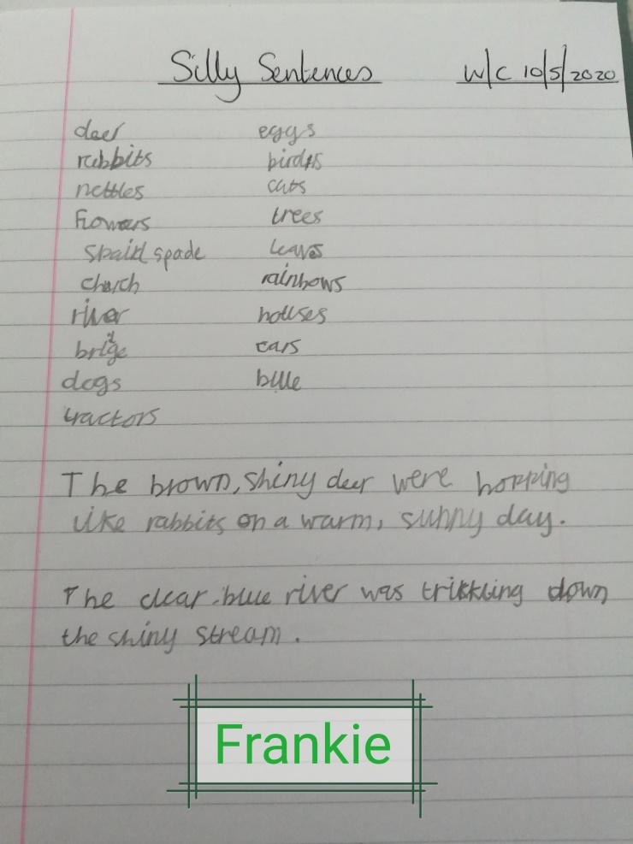
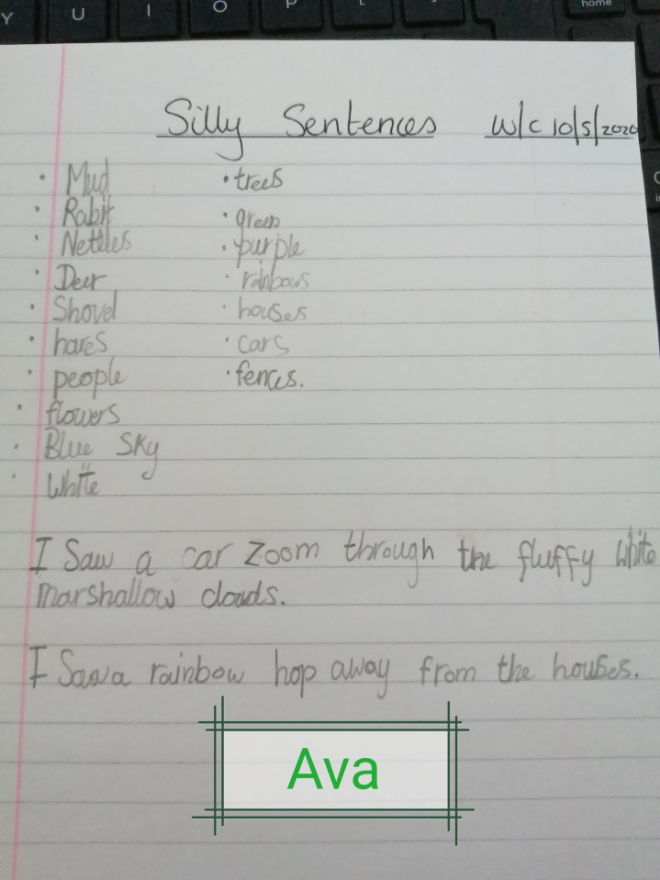
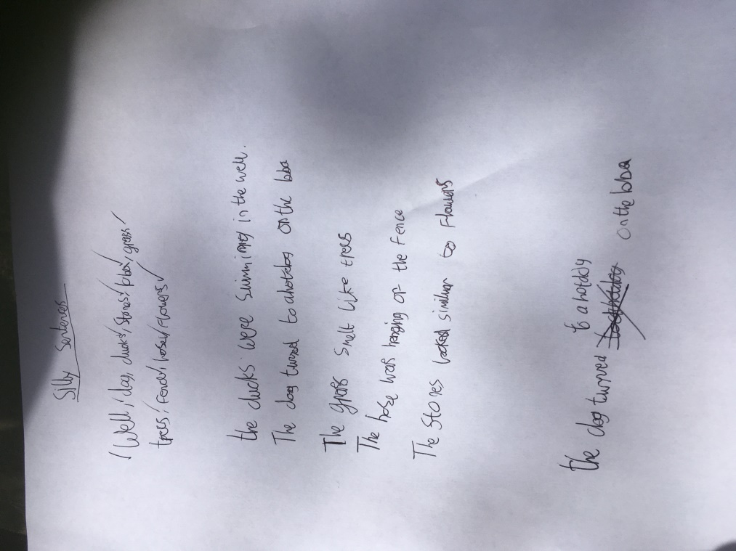
Silly Sentences!
Liam
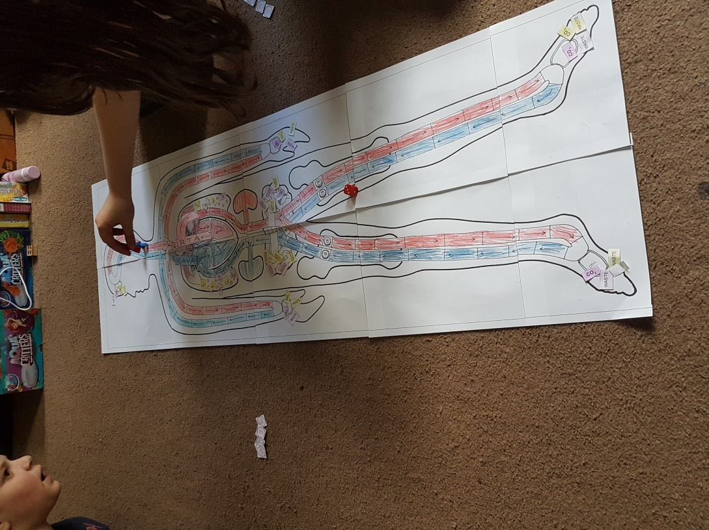
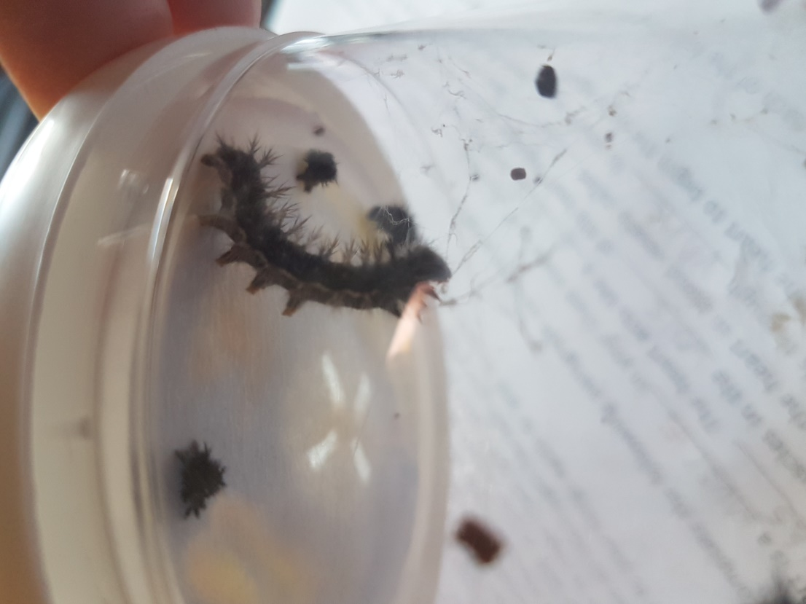
Harry and Megan are playing the circulatory system game!
Science Learning at home!

Harry and Megan are watching their caterpillars as they slowly develop into butterflies.
Oxygenated blood from the heart

Deoxygenated blood to the heart
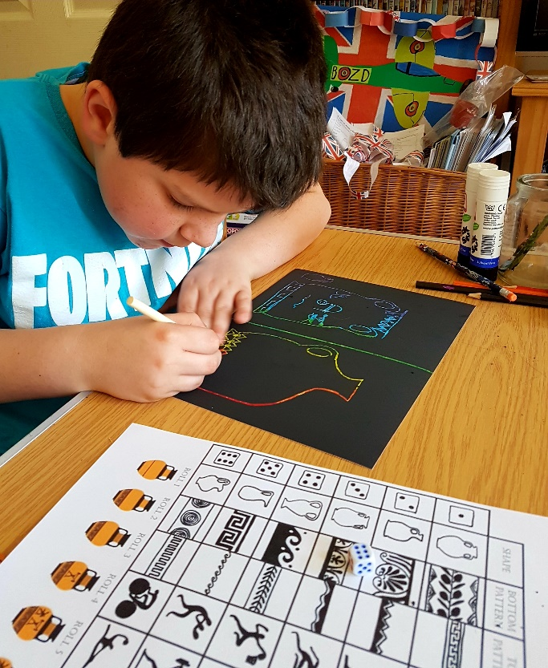
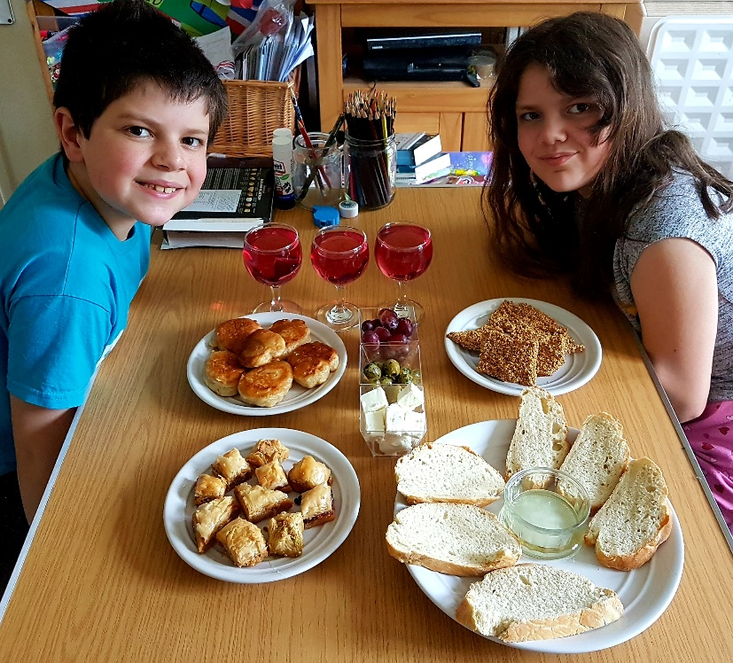
Ancient Greek Day

Designing greek vases using scratch art techniques.
Greek cuisine…..bread, sesame bars, honey dipped doughnuts, feta cheese, olives and baklava… What a feast!
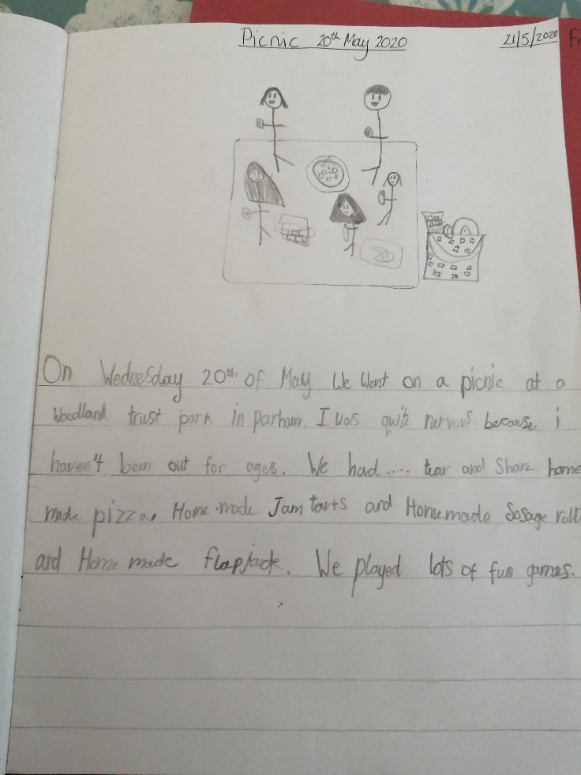
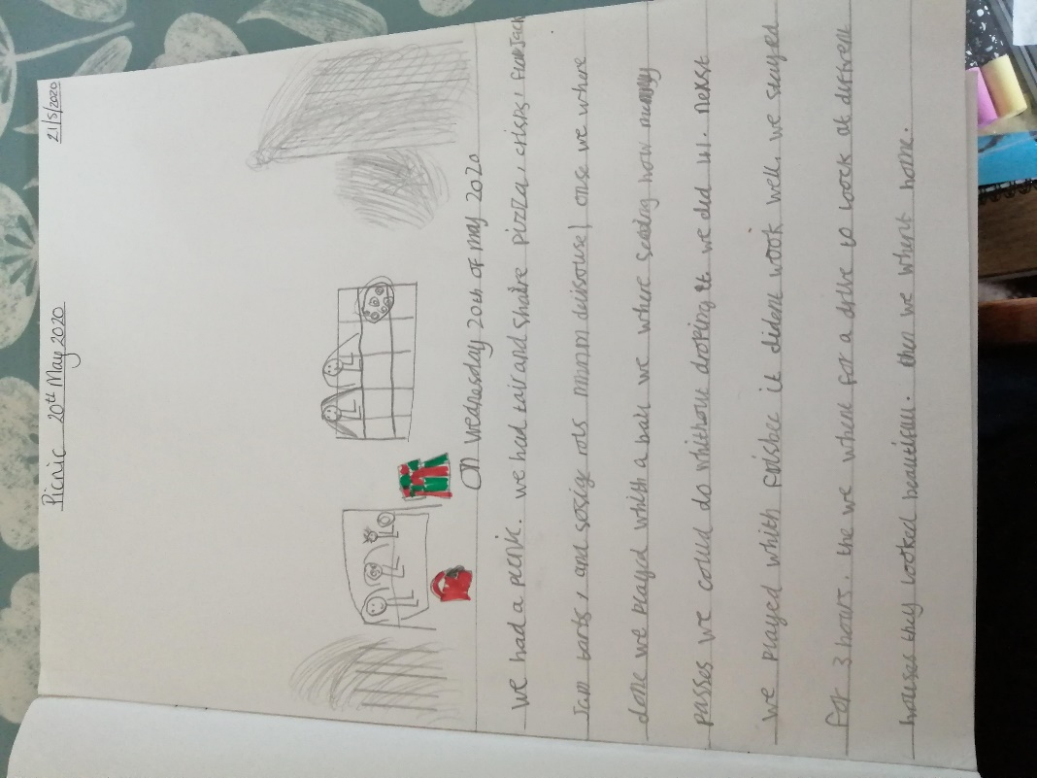
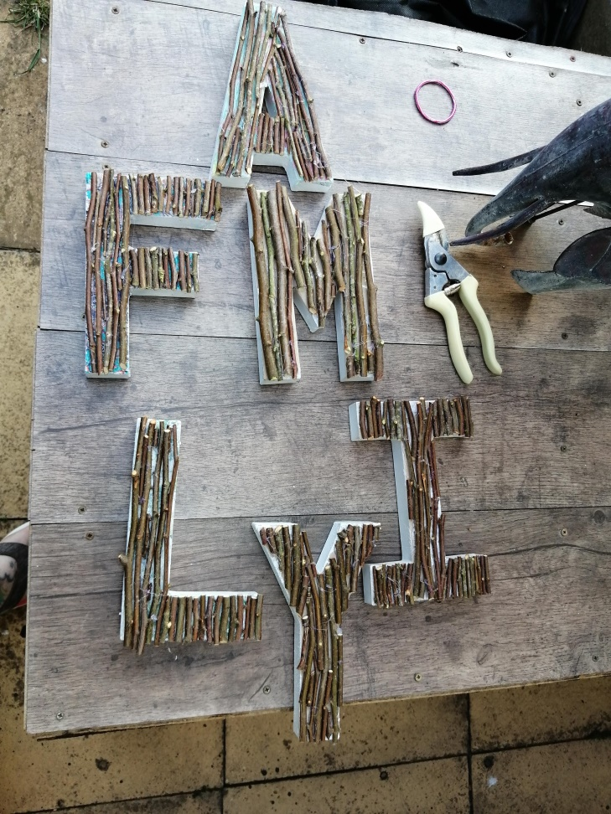
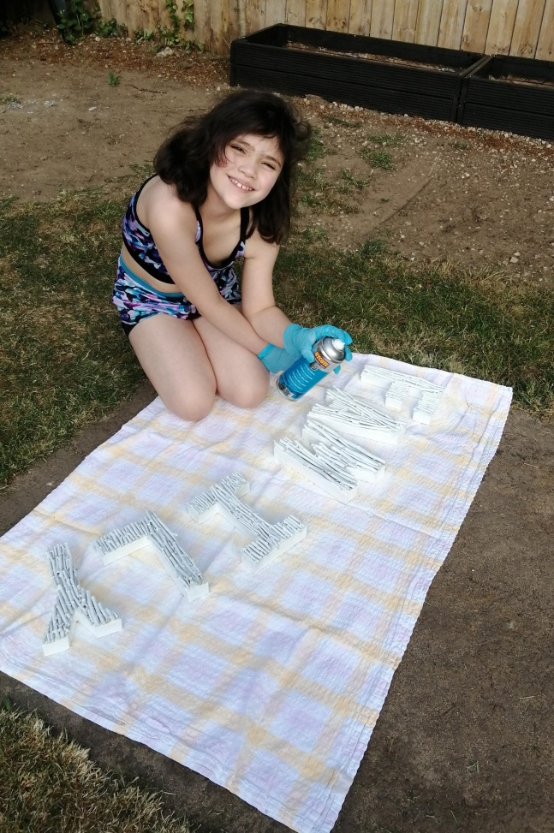
Picnic Time! Independent writing by Ava and Frankie
Frankie busy arranging twigs to create a beautiful plaque for their home. Looks a lot of fun!

