VE Day
Photographs of some of the ways Class 2 have commemorated VE Day on Friday 8th May 2020
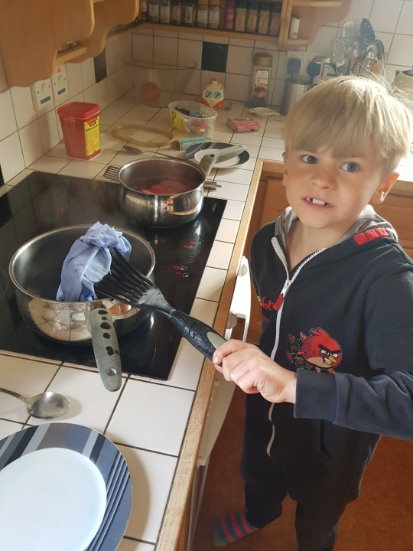
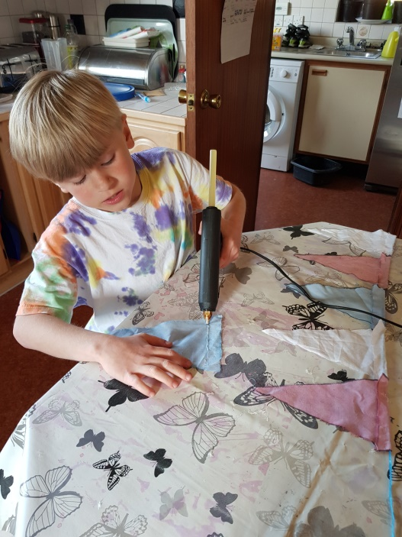
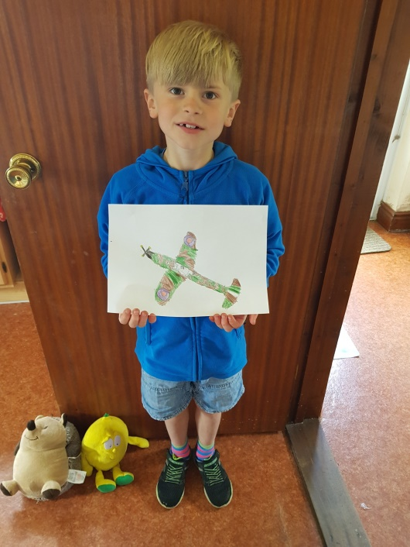
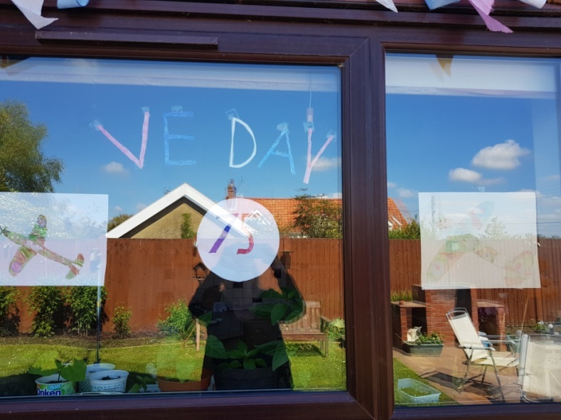
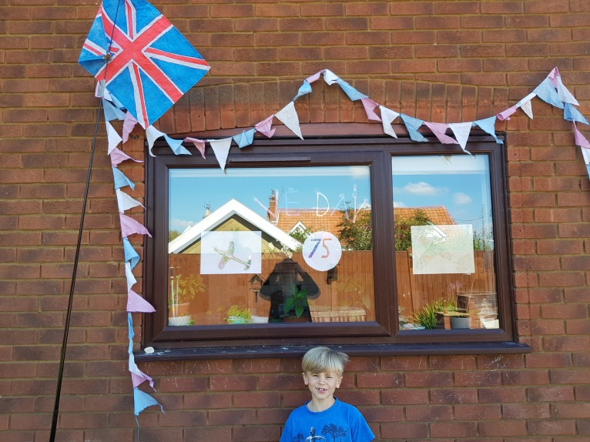
Making bunting by dying fabric red, white and blue, cutting it into triangles and then hanging it around the windows.
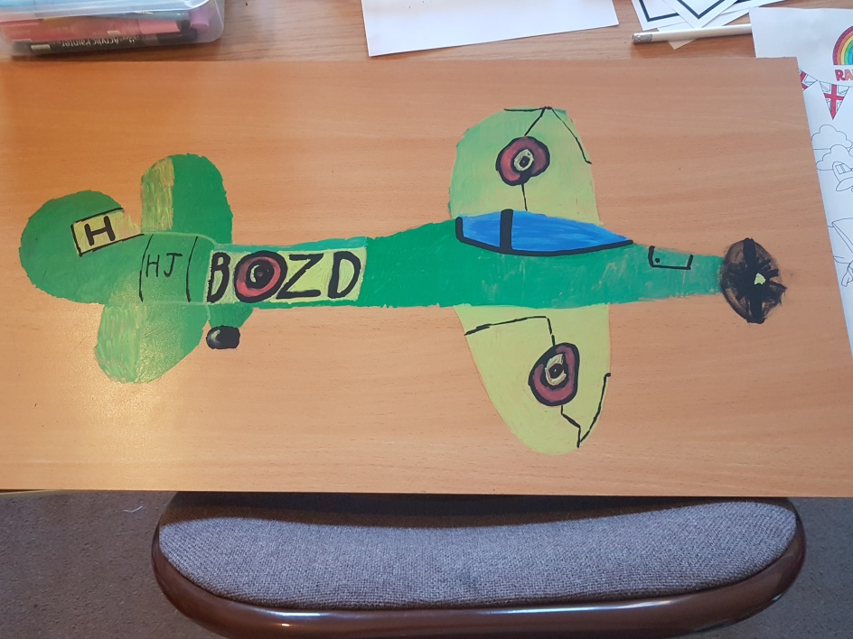
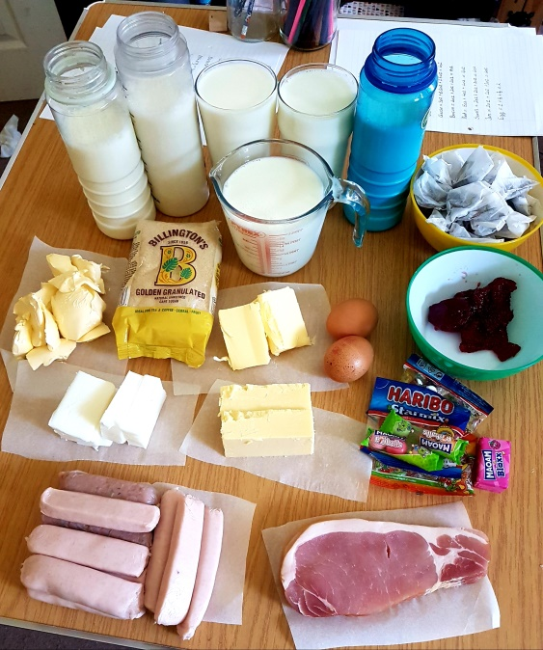
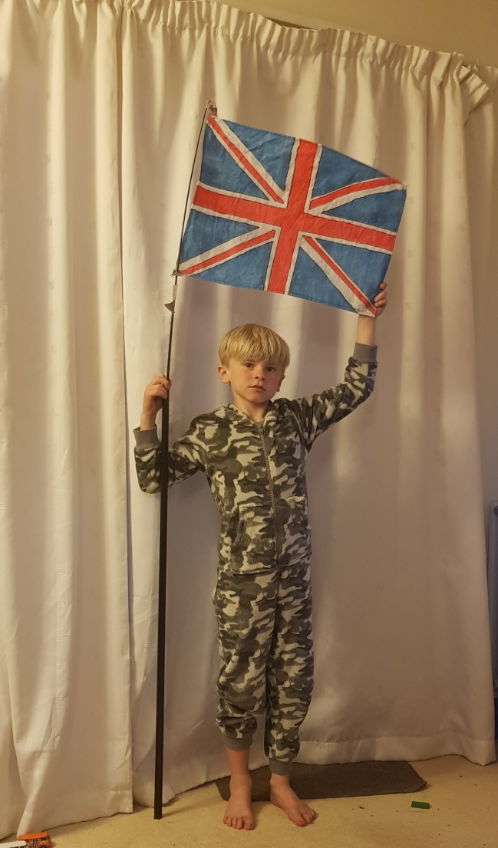
Dressed in army uniform with the Union Jack flag.
Harry and Megan measured and weighed out what their family would have had for a week of rations.
Harry painted this spitfire, a British single-seat fighter aircraft that was used by the Royal Air Force before, during, and after World War II.
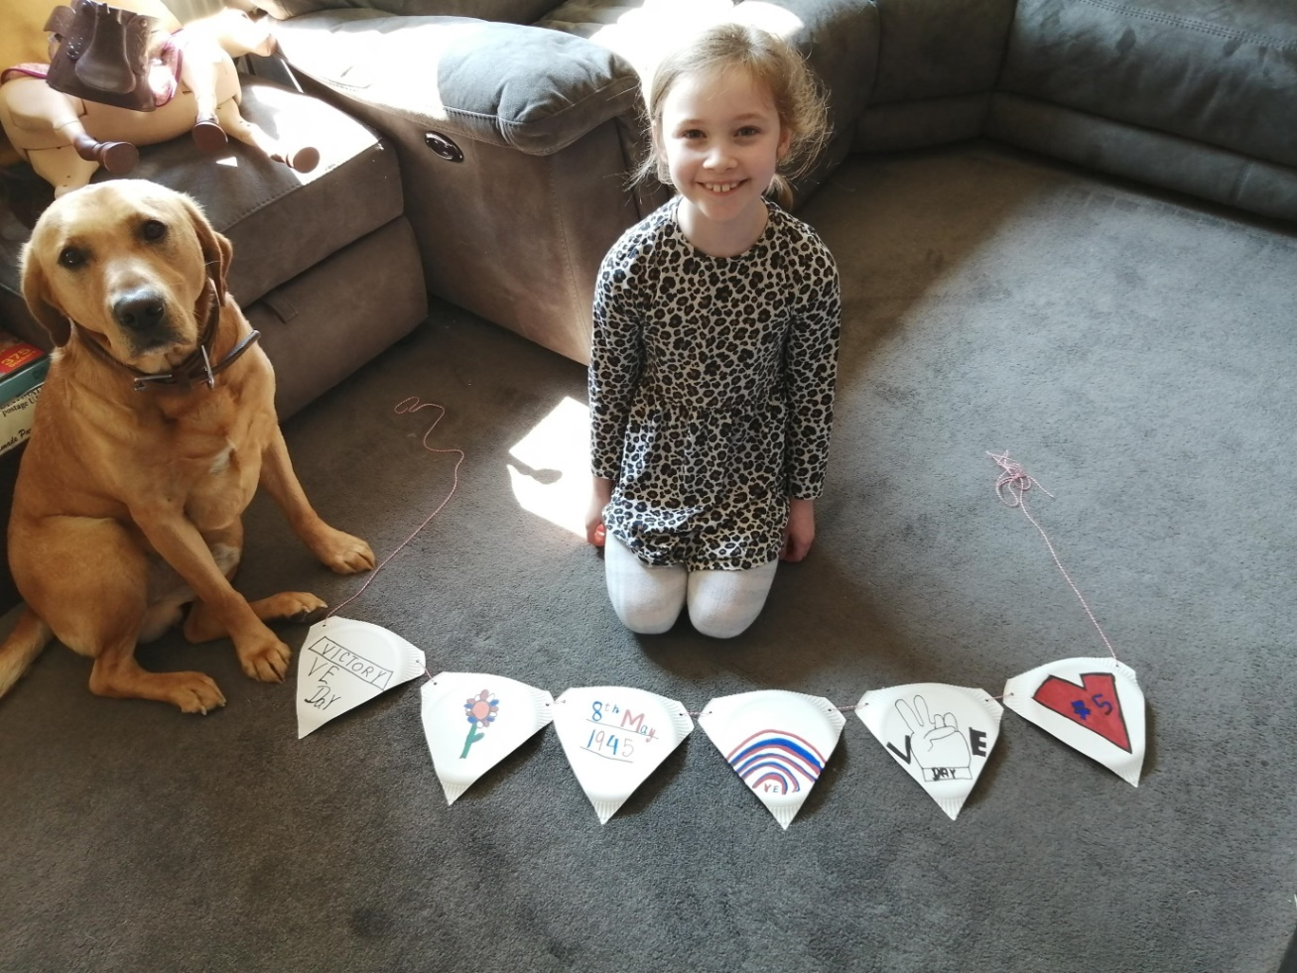
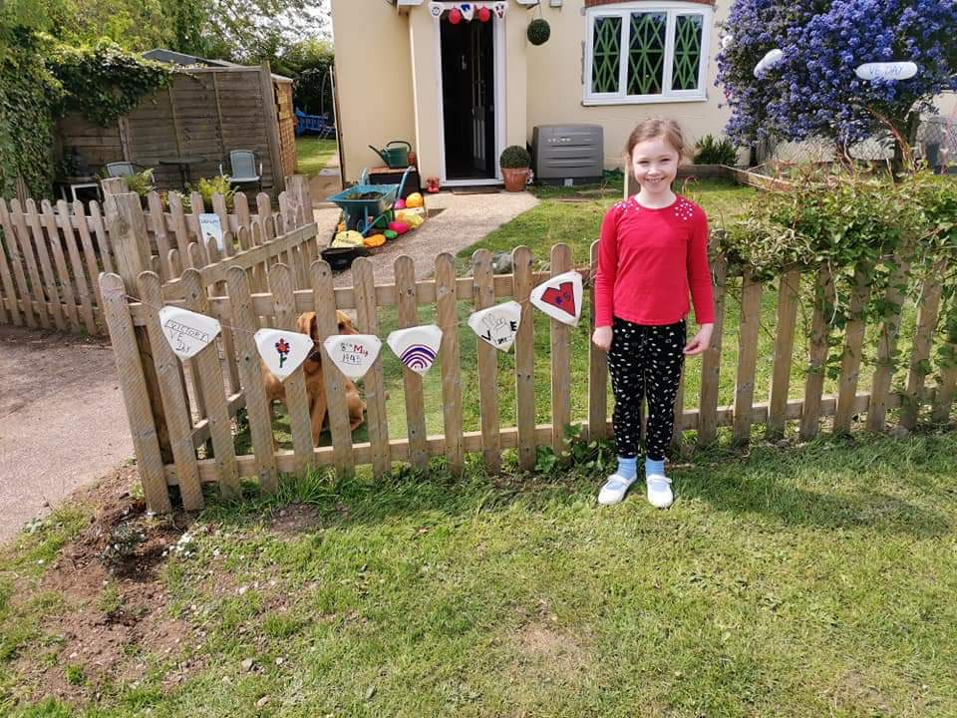

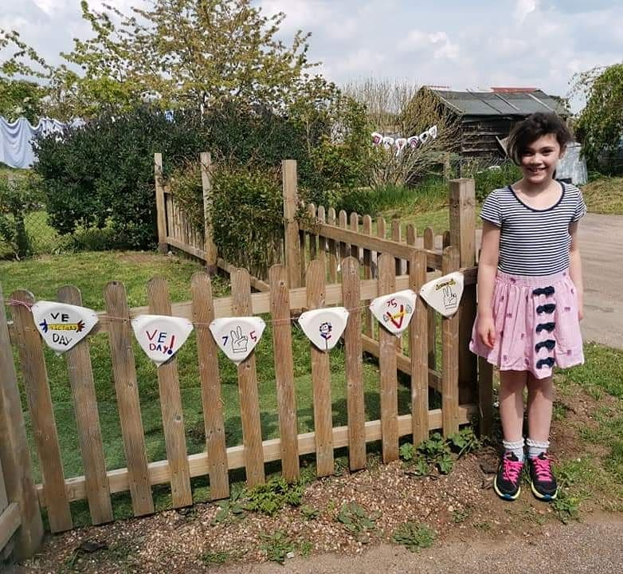
Great bunting girls!
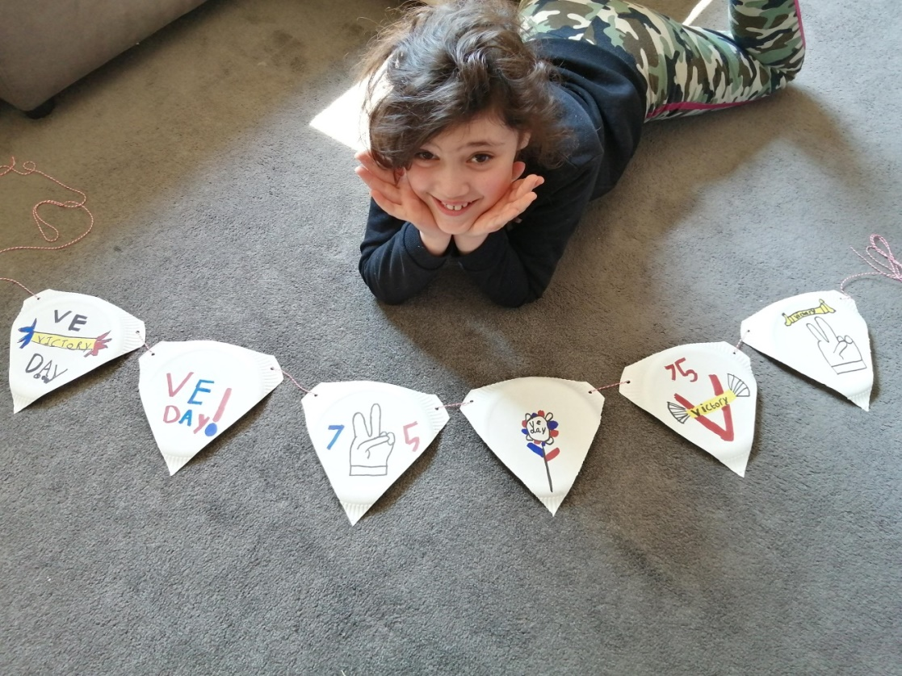
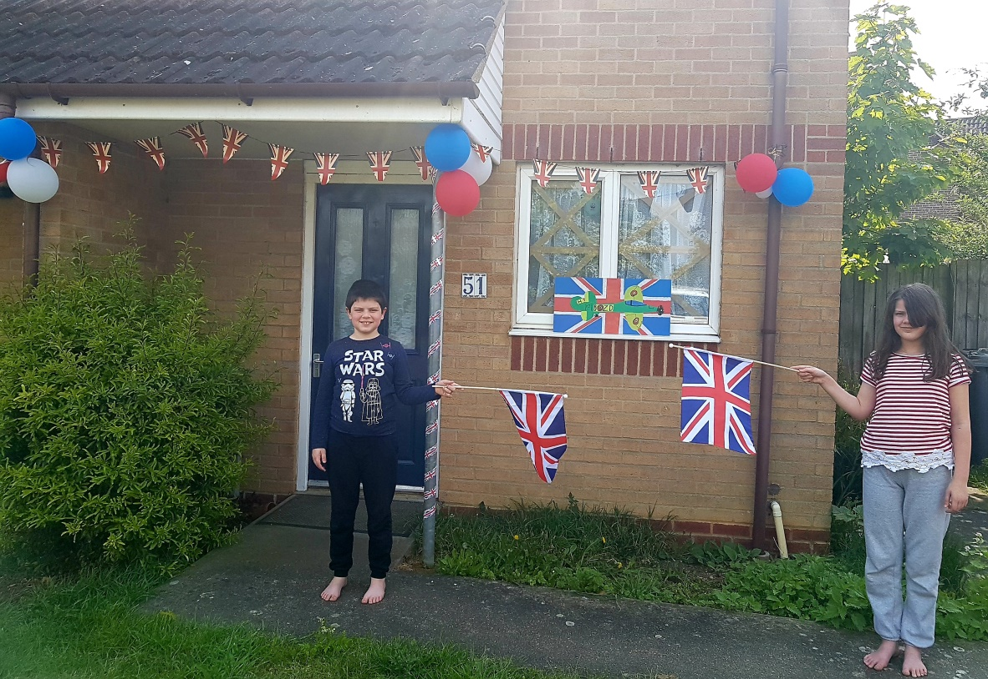
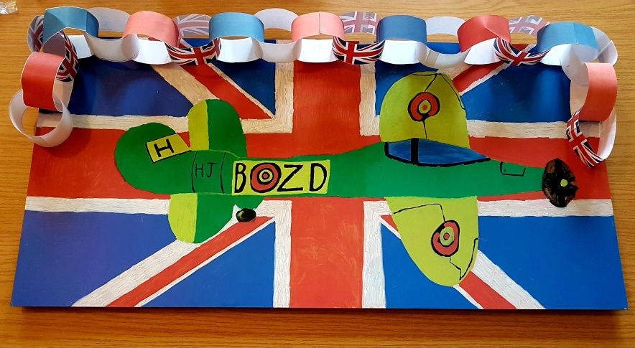
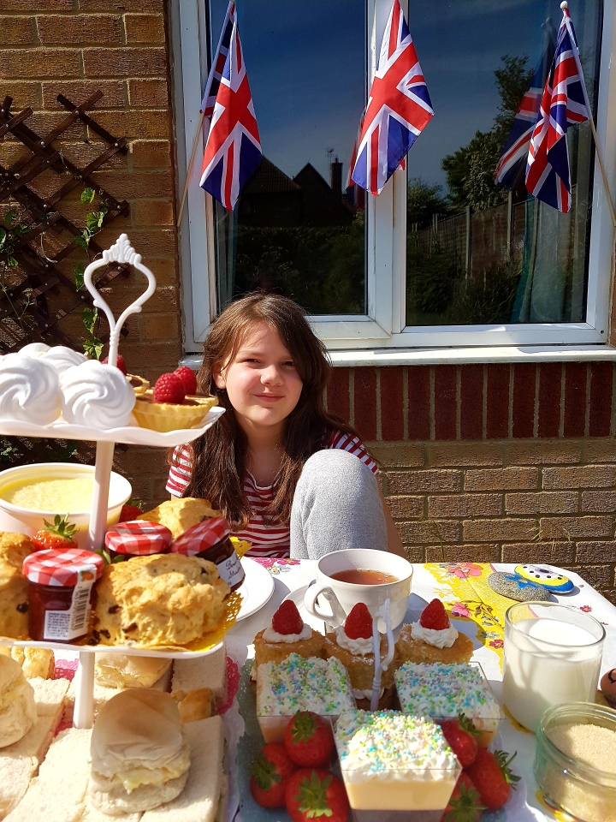

A picnic fit for a king …. or queen!

Harry and Megan celebrate VE Day in style!.

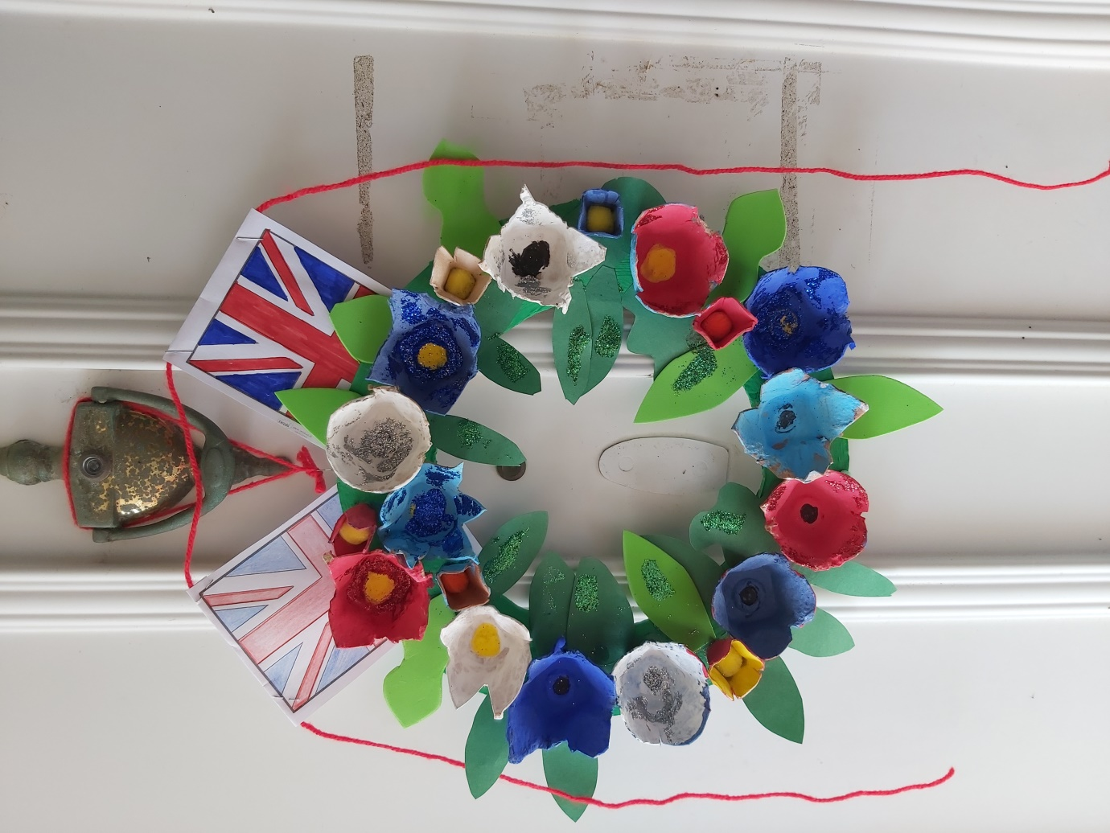
Phoebe, Logan and Mum made a beautiful commemorative wreath for their front door.


VE Day treats



