Stick Man Stories!

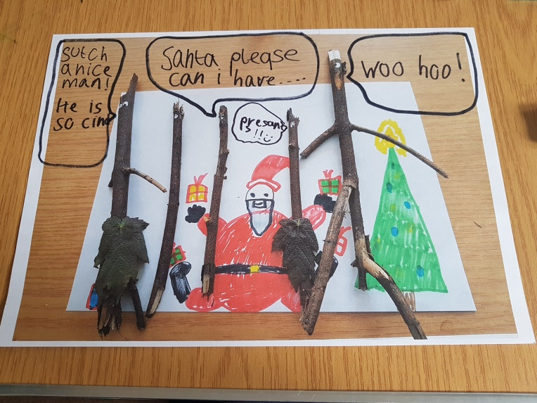
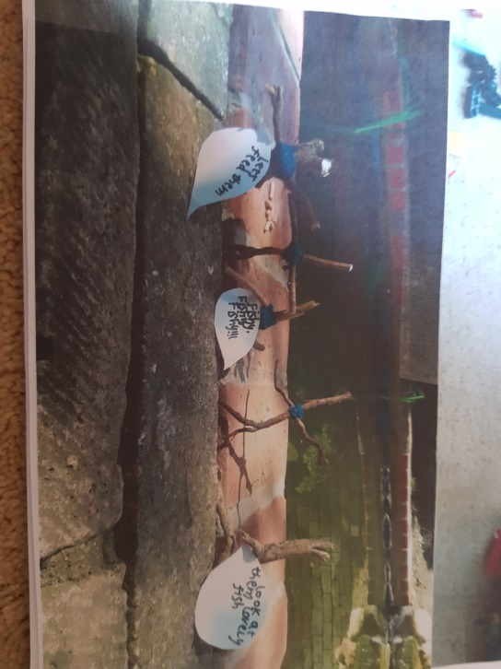
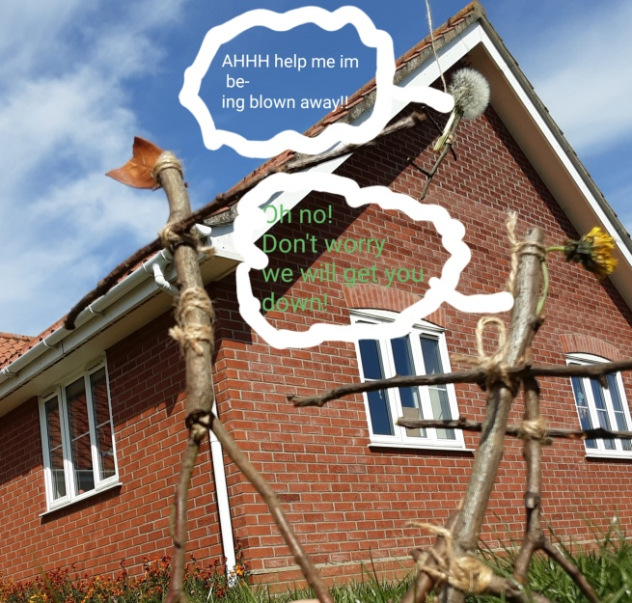
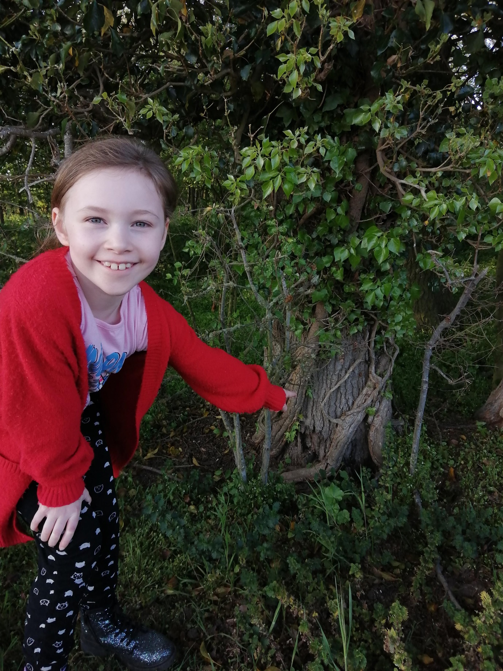
By Harry
By Thomas
By Phoebe
The real Stick Man has been found!

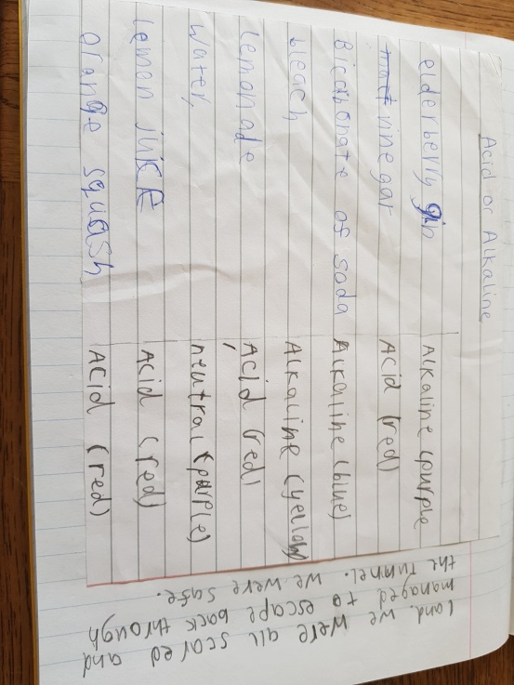
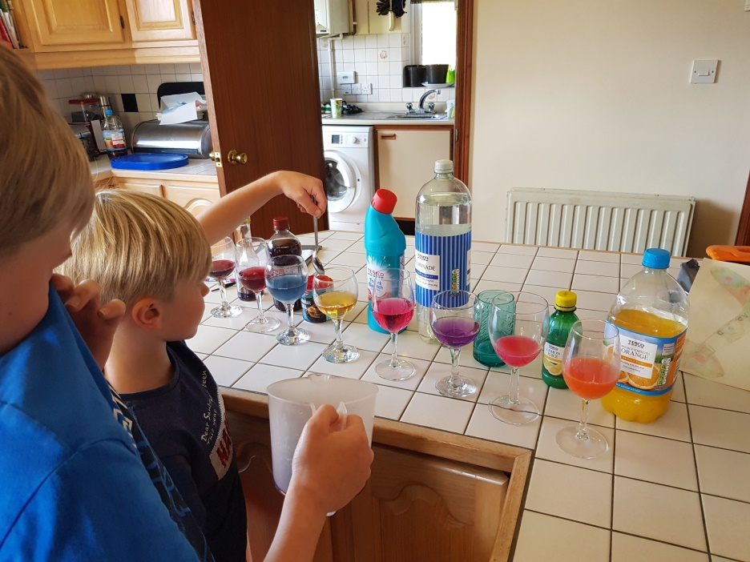

Is it an acid or an alkali? Thomas investigates by following Mr William’s cool kitchen science experiment.

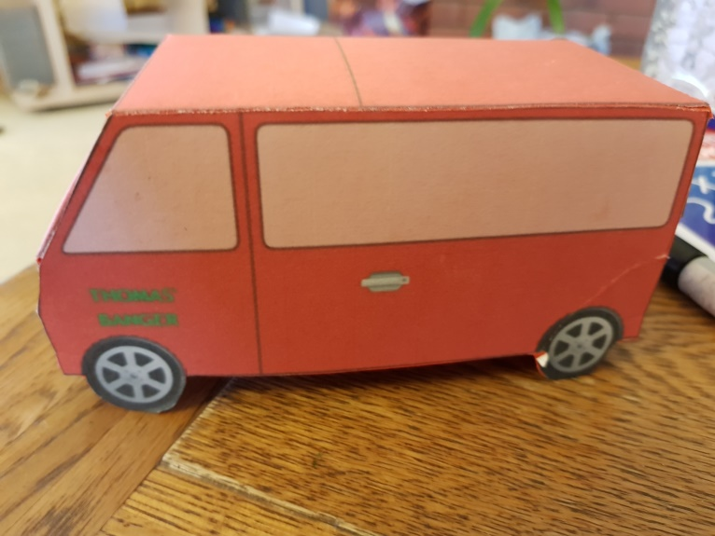
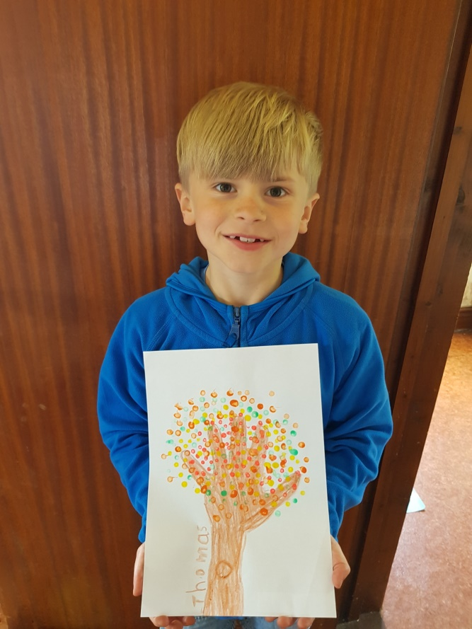
An example of pointillism in art.
Thomas has created a vehicle from a template he designed on Purple Mash. Doesn’t it look smart?
Art work using pointillism

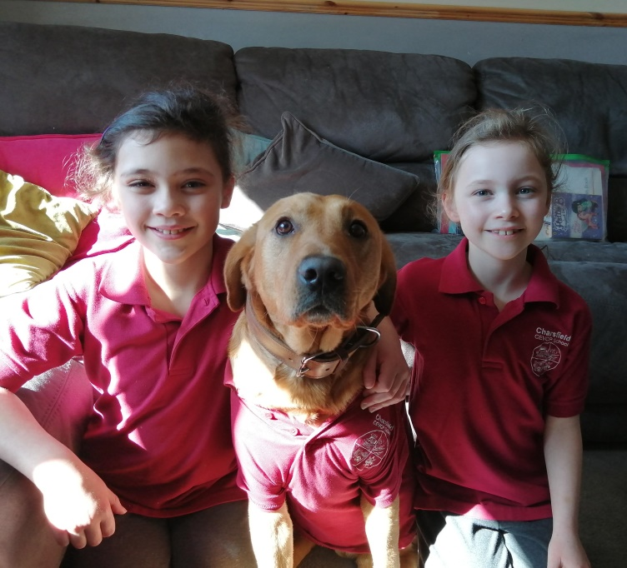
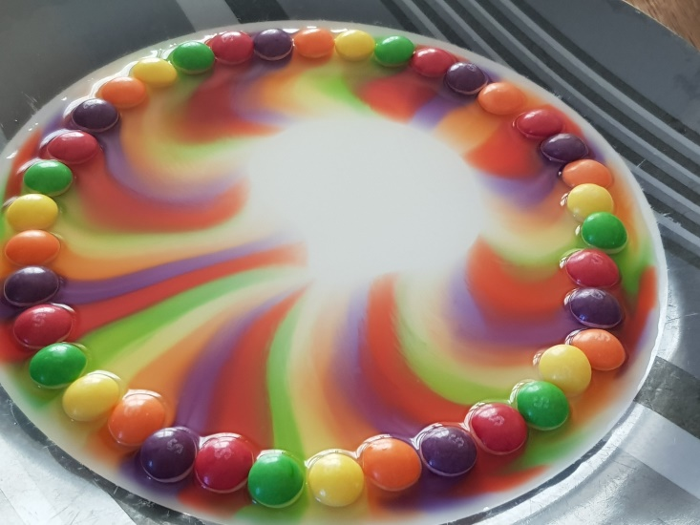
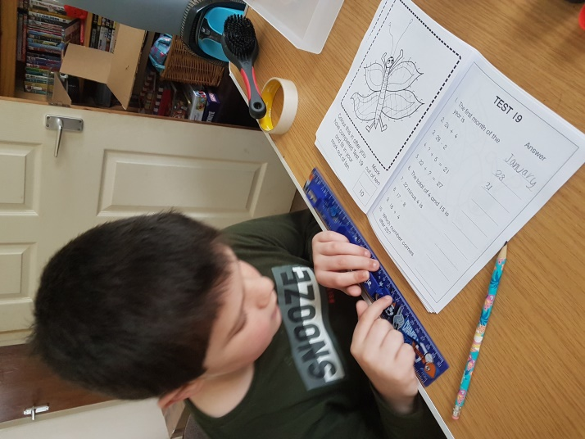
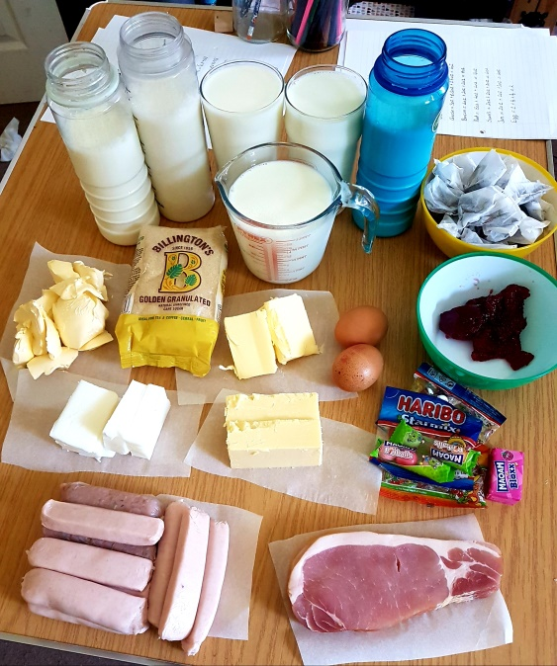
VE Day

Thomas has arranged skittles around a plate, added water and created a fascinating pattern! Perhaps you could have a go?
Mental maths time!
New student!
Harry and Megan measured and weighed out what their family would have had for a week of rations.
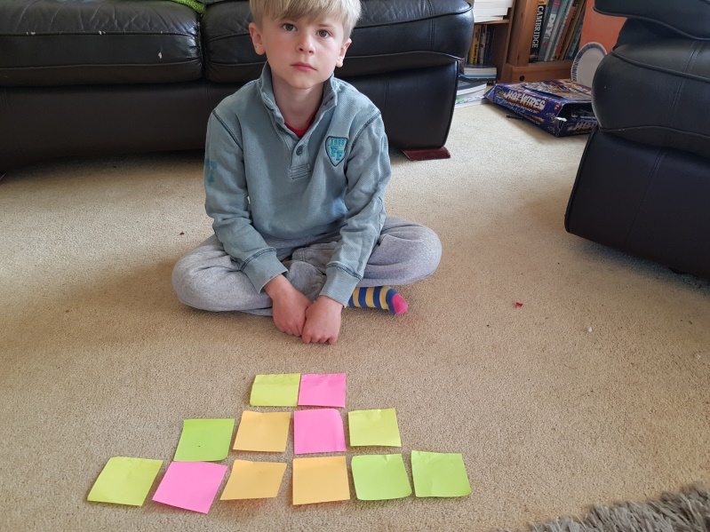
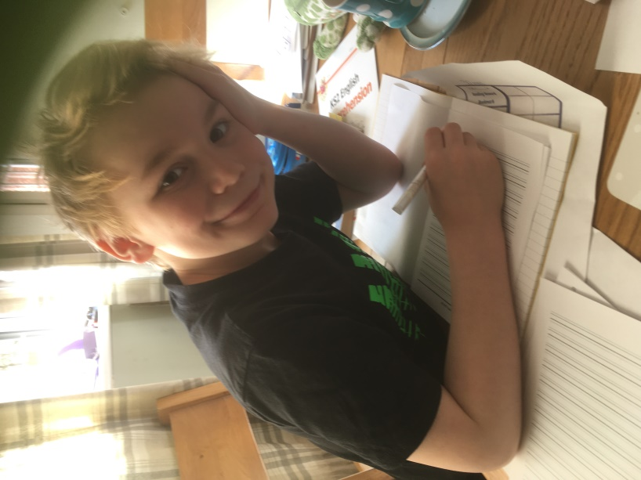
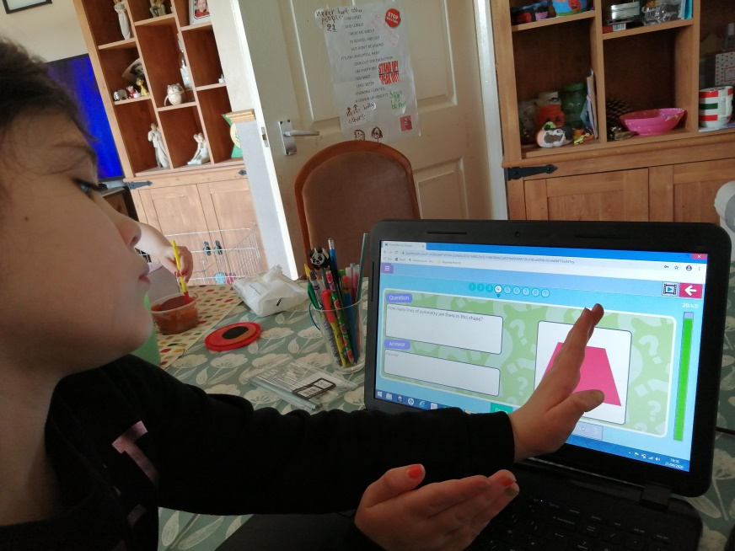
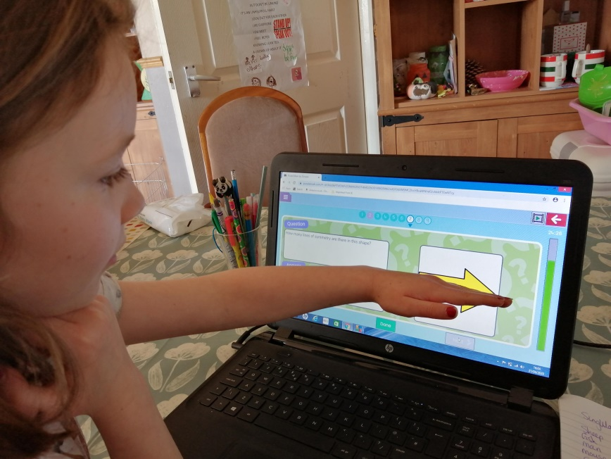
Thomas is using squares to investigate perimeter and area.
Hard at work looking very studious!
Working out lines of symmetry on Purple Mash.
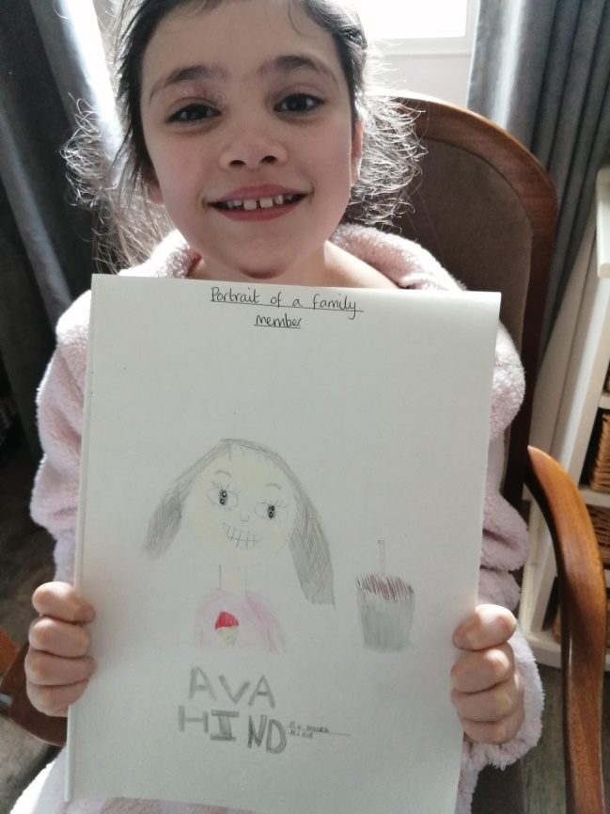
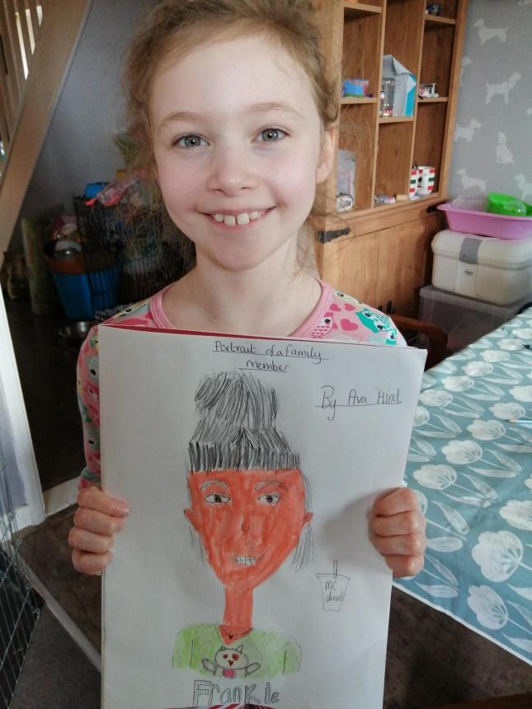
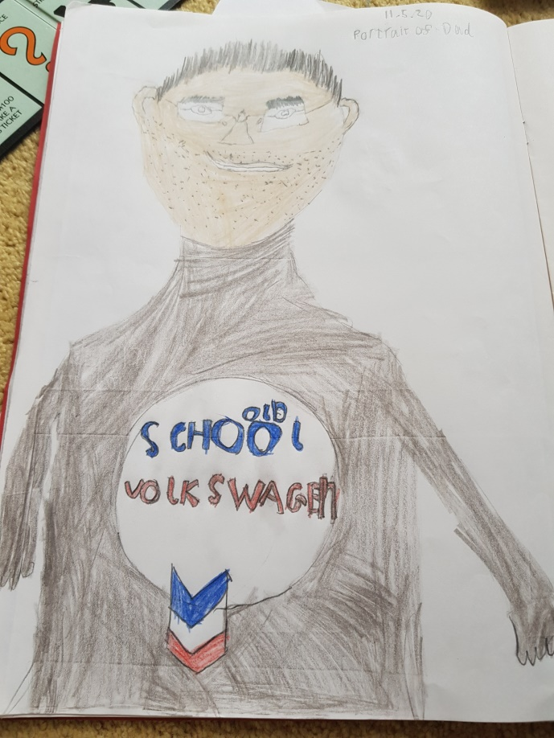
Can you guess which family member Thomas has drawn?

Having fun drawing each other!

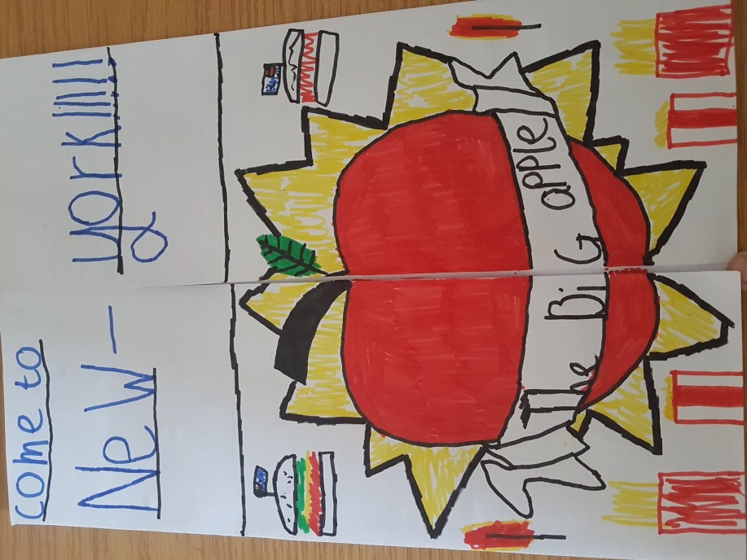
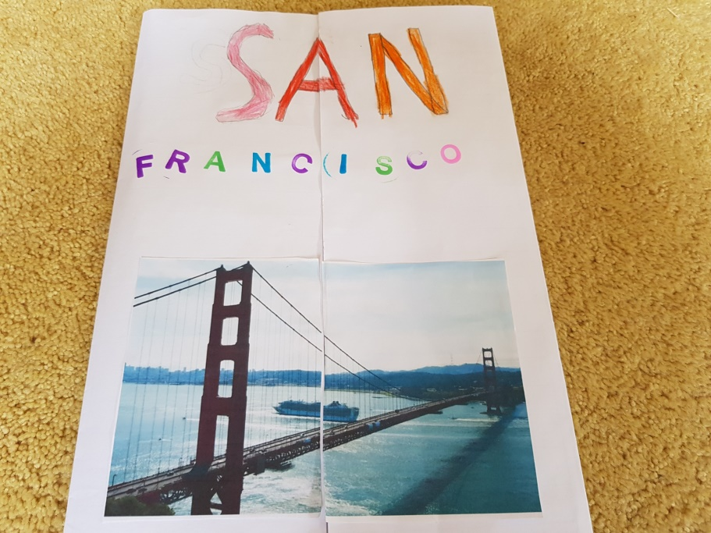
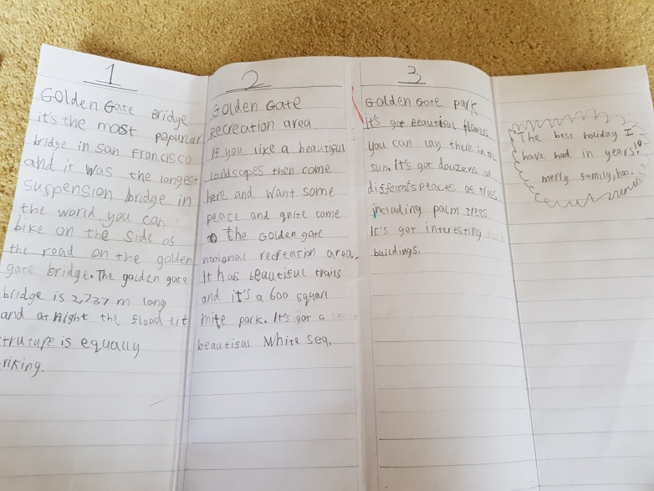
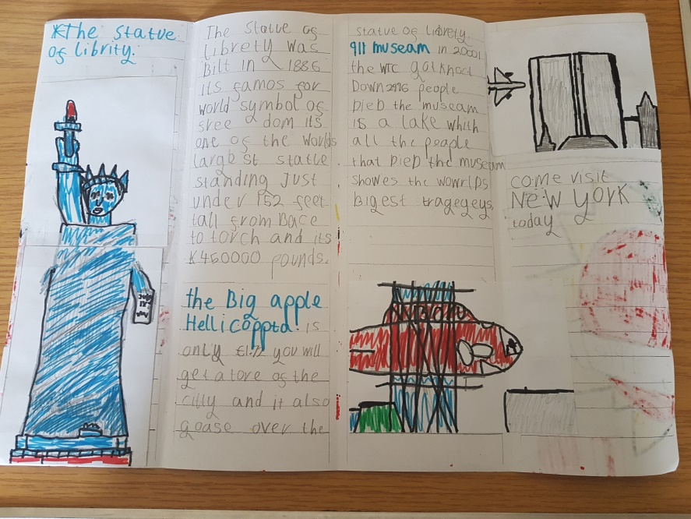
Persuasive Travel Brochures

By Harry
By Thomas
Easter Gardens

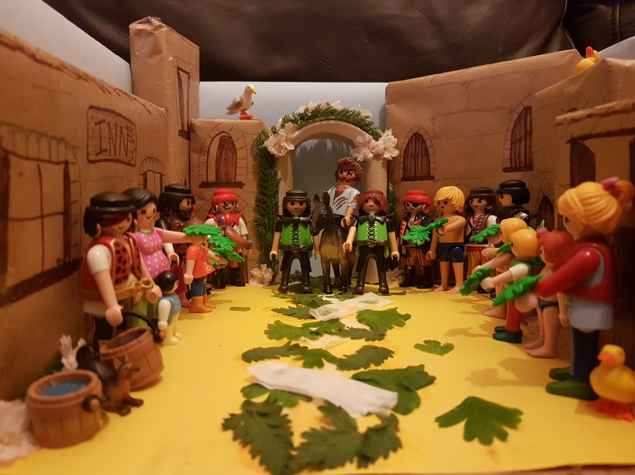
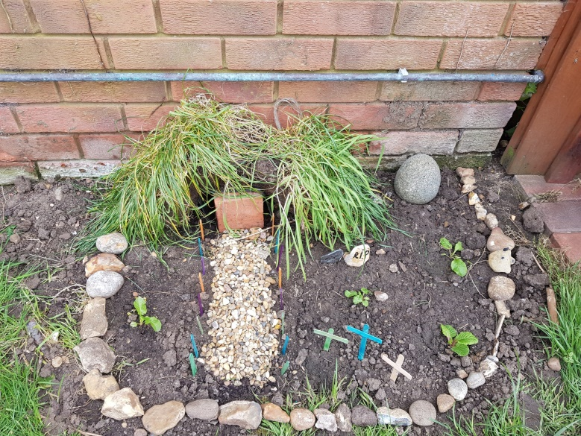
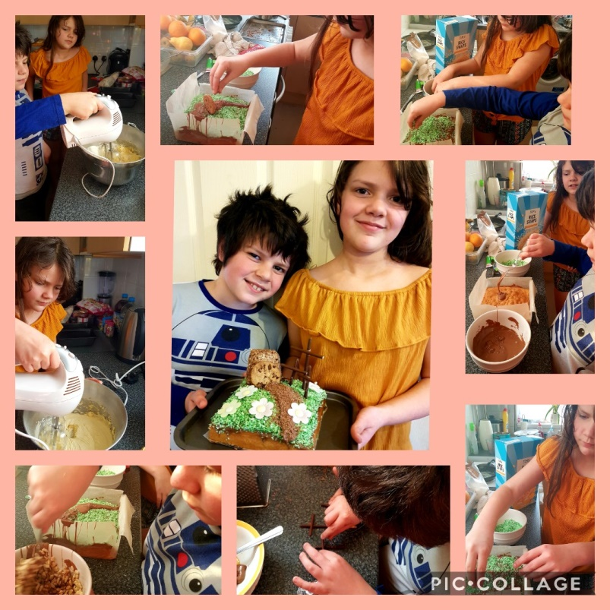
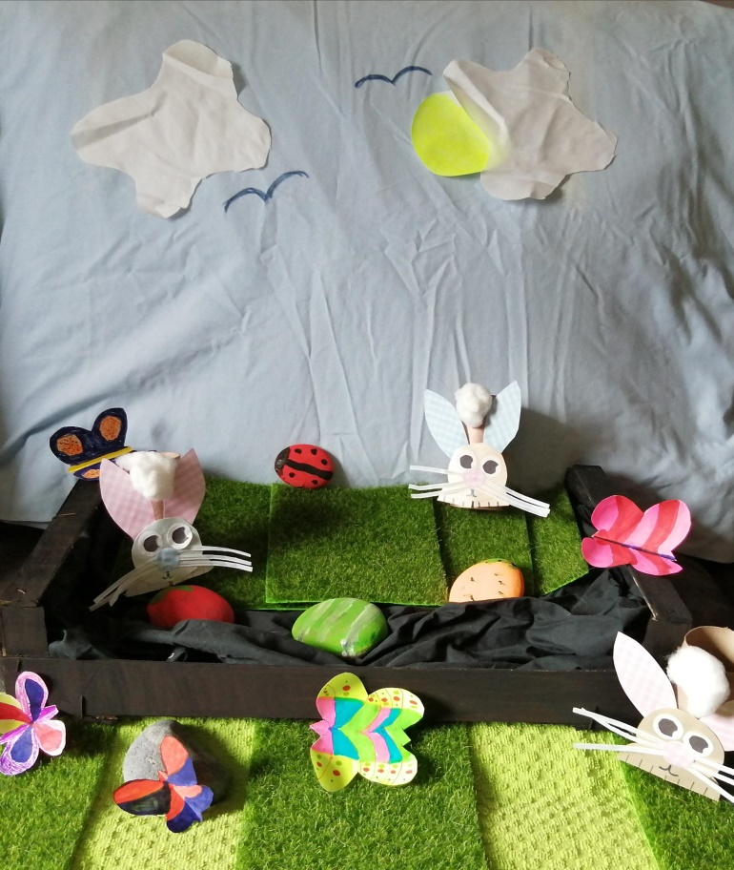
Ava and Frankie are very proud of their Easter Garden.
What a delicious looking Easter Garden cake! See you on Bake-Off!

Harry and Megan recreated the scene depicting Jesus as he arrives in Jerusalem on Palm Sunday.
Thomas’ Easter Garden.
Can you spot the crosses?
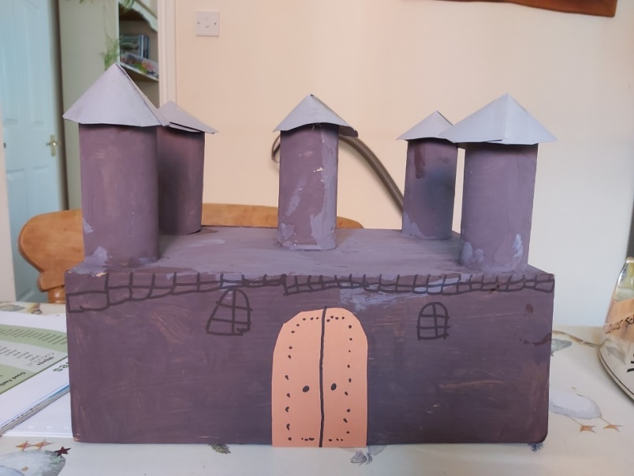
Book in a box project

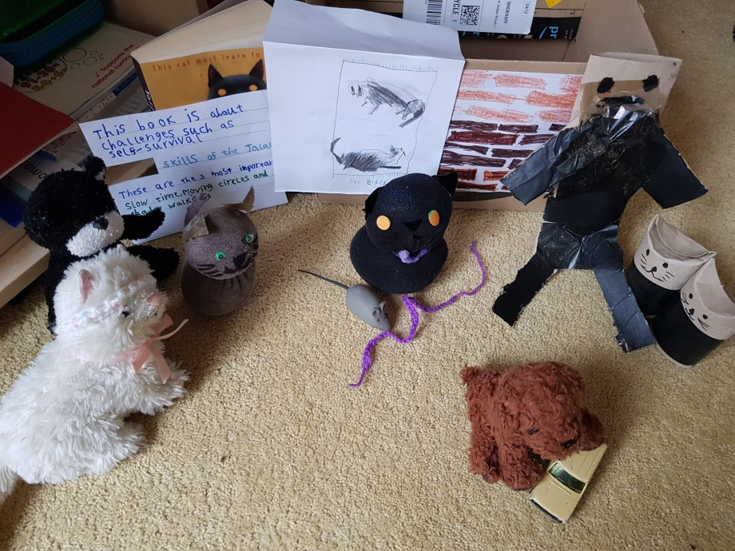
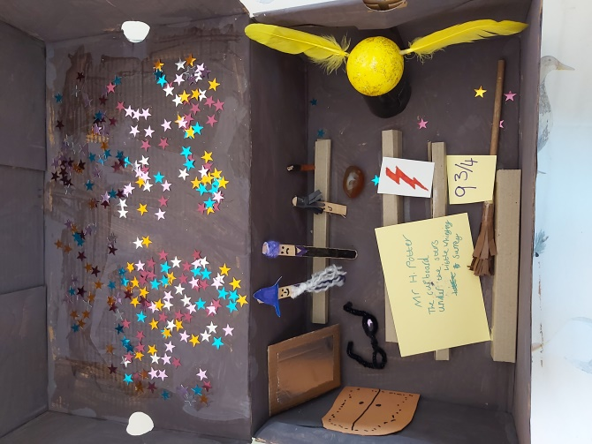
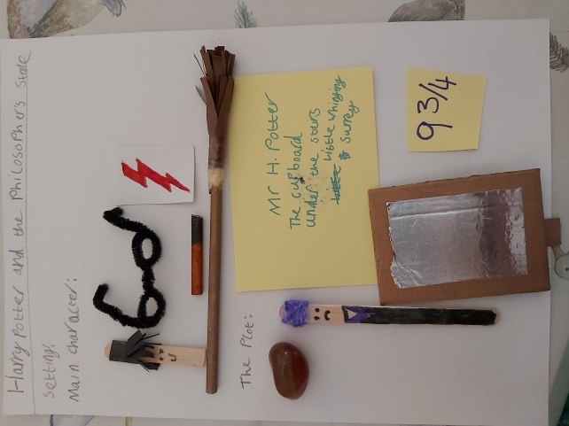
Can you guess the title of the book in a box made by Thomas?
Phoebe’s book in a box project. Can you guess the name of this famous children’s book?
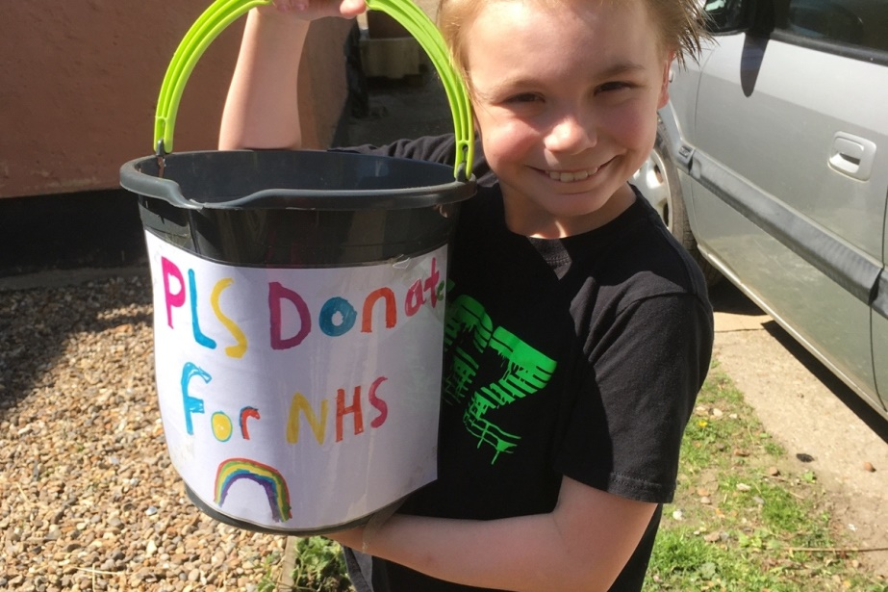
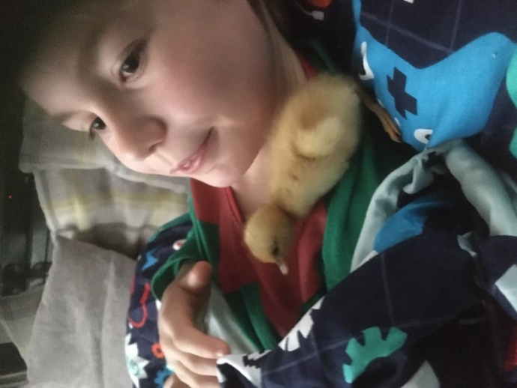
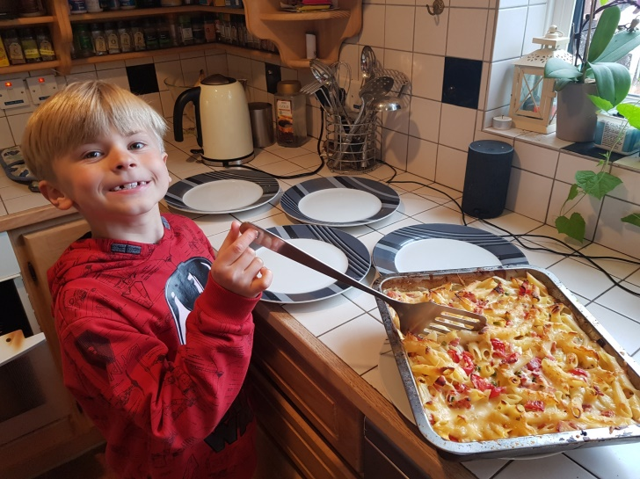
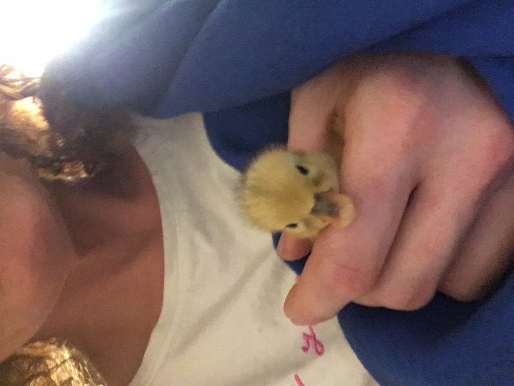
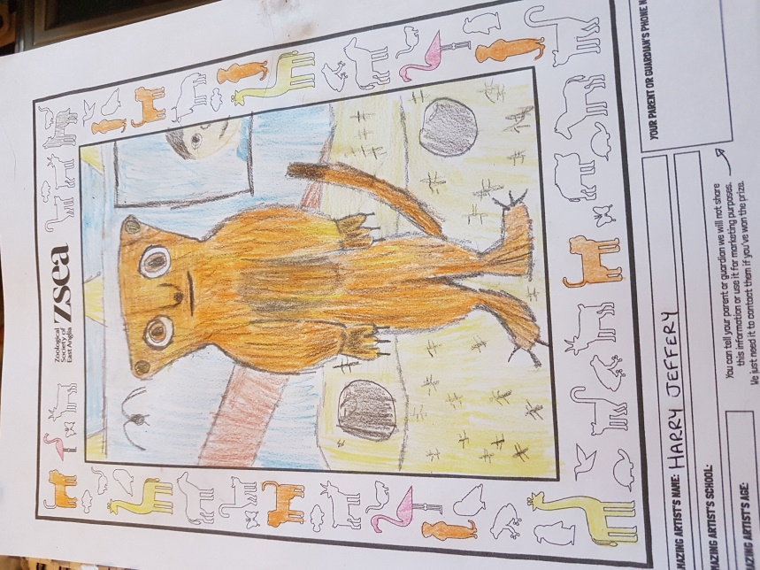
Harry’s entry for Banham Zoo competition.
Cooking a delicious pasta for tea! Bet there wasn’t much of that left over!
Meet Pineapple the abandoned duckling that has been adopted!
Raising money for the NHS…What a lovely thing to do!
Liam with Pineapple, the abandoned duckling that he adopted.

