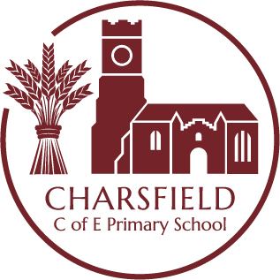

Continuous Provision WRITING AREA
Key Learning Opportunities
Personal, Social and Emotional Development Literacy
– To build constructive and respectful relationships - To develop the ability to form lower case and capital letters correctly.
- To express their feelings and consider the feelings of others. - To spell words by identifying the sounds and then writing the sound with letters.
Communication and Language - To begin to form marks, letters, phrases and full sentences.
- To extend vocabulary, by learning and using new vocabulary. Mathematics
- To articulate their ideas and thoughts in well-formed sentences - To recognise numerals
- To describe events in some detail
- To use talk to help work out problems and organise thinking and activities.
Expressive Arts and Design
Physical Development - To explore, use and refine a variety of artistic effects to express their ideas and feelings.
- To develop their small motor skills so that they can use a range of tools competently, safely and
confidently - To return to and build on their previous learning, refining ideas and developing their ability to
- To use their core strength to achieve a good posture when sitting at a table or on the floor. represent them.
- To develop the foundations of a handwriting style which is fast, accurate and efficient. - To create collaboratively, sharing ideas, resources and skills.
- To develop an effective pen grip.
Resources | Intended Experiences | Role of the Adult
- A selection of mark making tools, including selections of pencils, pens, whiteboard pens, chalk, crayons, felt pens, pencil crayons, highlighters.  - Paper, card, envelopes, postcards, recipe and letter templates, whiteboards.  Enhancements  Think about the time of the year and how this can naturally link to festivals, communities, seasons e.g. Christmas cards, thank you letters | - Making decisions about the resources they need  - Handling and using resources appropriately  - Managing and organising resources, getting things out and tidying away  - Playing alongside and with others  - Communicating, sharing ideas, negotiating and co-operating  - Making notes, lists, postcards, recipe books, birthday cards, fact files  - Retelling stories and events  – Talking about what they are doing, sharing their ideas | Play alongside  - Observe children and take note of their key interests  - Respond to their requests and ideas  - Suggest possibilities to extend their mark making  - Consider additional stimulus and add this immediately if to hand or the following day/week  - Write/draw alongside children to take learning forwards, suggest ideas and show what’s possible  Role model / direct teach  - Model correct formation using a memorable phrase and demonstrating a correct pen grip  - Model the starting position and direction for forming letters correctly.  - Model language, correct and/or extend vocabulary  - Model composing ideas orally before writing  Raise questions to stimulate ideas and add challenge  - I wonder what other patterns/marks/letters you could make?  - Can you tell me about…?  - Can you?  Use appropriate language linked to key learning  - Communities and festivals (celebrations, Christmas, Diwali, New Year, Eid)  - Seasons (autumn, winter, spring, summer)  - Family (mum, dad, aunt, uncle, sister, cousins, neighbours)

