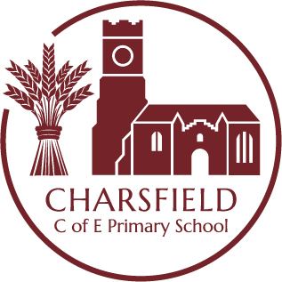

Continuous Provision SMALL WORLD AND CONSTRUCTION INDOOR AREA
Key Learning Opportunities
Personal, Social and Emotional Development Physical Development
– To build constructive and respectful relationships - To develop their small motor skills so that they can use a range of tools competently,
- To express their feelings and consider the feelings of others. safely and confidently
- To show resilience and perseverance in the face of challenge. - To develop the overall body strength, co-ordination, balance and agility
- To identify and moderate their own feelings socially and emotionally. - To combine different movements with ease and fluency
- To think about the perspective of others. - To confidently and safely use a range of small apparatus inside, alone and in a group
Communication and Language Literacy
- To extend vocabulary, by learning and using new vocabulary. - Use new vocabulary in different contexts
- To understand how to listen carefully and why listening is important Expressive Arts and Design
- To ask questions to find out more - To return to and build on their previous learning, refining ideas and developing their
- To articulate their ideas and thoughts in well-formed sentences
- To describe events in some detail ability to represent them
- To use talk to help work out problems and organise thinking and activities, and to explain how things work - To create collaboratively, sharing ideas, resources and skills and why they might happen. - To develop storylines in their pretend play
Resources | Intended Experiences | Role of the Adult
Mobilo, duplo, lego, sticklebricks, magnetix, wooden blocks, cars, animals, dolls house, wooden figures, wooden structures for building Loose parts – grass, pebbles and stones, small logs, shells  Mark making and writing  A selection of mark making tools nearby including selection of pencils, pens, A5, A4 and A3 note pads, whiteboards and pens, and clipboards.  Enhancements: Linked to theme or interests such as books, images or small world | Making decisions about the resources they need  - Caring for resources appropriately  - Sharing, co-operating and collaborating  - Planning, negotiating and compromising  - Talking about what they are doing, describing their actions, what they see happening, sharing their ideas and responding to their requests  - Sharing imaginative and creative thoughts  - Exploring resources to see what they can be made to do  - Creating structures of different shapes and sizes such as towers  - Building familiar things for example, vehicles  - Building imaginary places and objects  - Making up stories, acting out events  - Pretending to be characters, creating imaginative and real-world scenarios  - Persisting from an idea through to a conclusion | Play alongside  - Observe children and tune into their interests  - Help children with what they are trying to do and comment on their actions  - Suggest possible ways to extend their thinking  - Encourage children to persist and to have another go  - Consider additional stimulus and add this immediately if to hand or the following day  Role model/direct teach  - Model how to access stored resources  - Model and manage behaviours, self-regulation and the characteristics of effective learning  - Teach children the skills and techniques of building for example, how to fix and fasten materials together  - Model retelling stories  Raise questions to stimulate ideas and add challenge  - What do you notice about…?  - I wonder how/what would happen if…?  - Can you tell me about…?  Use appropriate language linked to key learning  - Mathematical language; shape, space, size and position  - Scientific language; materials, gravity, stability  - Technology and engineering; structures and vehicles  - Geographical language linked to places  - Story language  -Emotional well-being linked to creating spaces

