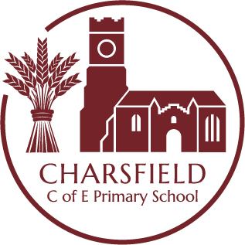

Continuous Provision READING AREA
Key Learning Opportunities
Communication and Language Literacy
– Understand how to listen carefully and why listening is important. All of the Development Matters reading learning intentions could be
- Learn new vocabulary and use throughout the day provided for in the Reading area in the later part of the Reception year, as
- Engage in story times. the children have a growing understanding of phonics: reading letters,
- Listen to and talk about stories to build familiarity and understanding. blending to read words, reading common exception words, become familiar
- Retell the story, once they have developed a deep familiarity with the text; some as exact repetition and some in their with books by re-reading them.
own words. Understanding the World
- Listen carefully to rhymes and songs, paying attention to how they sound. - Comment on images of familiar situations in the past.
- Learn rhymes, poems and songs. - Compare and contrast characters from stories, including figures from the
- Engage in non-fiction books.
- Listen to and talk about selected non-fiction to develop a deep familiarity with new knowledge and vocabulary. past
Personal, Social and Emotional Development - Recognise some environments that are different to the one in which they
– Express their feelings and consider the feelings of others. live.
- Think about the perspectives of others.
Physical Development
- Use their core muscle strength to achieve a good posture when sitting at a table or sitting on the floor
Resources | Intended Experiences | Role of the Adult
Open shelves and storage boxes Large cushions  Soft toys and puppets.  Wide range of books - picture, fiction and rhyme, sound books, lift the flap books, non- fiction, multicultural/different needs, sensory, comics and catalogues, big books, home- made/photo books, books linked to themes or topics of interest, dual language books, instruction leaflets, recipe cards/books, Atlas, road/street maps.  Display relating to current interests/themes, children’s favourites books.  CD’s of rhymes, stories, songs and spoken words,  Story picture cards, story or rhyme sacks or boxes.  Objects and games to support phonological awareness (in separate shelves) Enhancements  Books relating to topics/themes | Discover how to handle books carefully.  Hold books the correct way up and turn pages one at a time.  Enjoy looking at pictures  Talk about, how characters from stories feel. Have some favourite stories, rhymes and poems.  Opportunities to use different voices to tell stories  Developing listening skills.  Use stories they hear in their play. Begin to be aware of the way stories are structured.  Suggest how the story might begin/end. Show interest in illustrations and print in books and their environment.  Understand that print carries meaning and is a means of communication.  Enjoy an increasing range of books. Understand that information can be retrieved from books. | Play alongside  - Observe children and take note of their key interests  - Respond to their requests and ideas  - Consider additional stimulus and add this immediately if to hand or the following day/week  Role model / direct teach  - Model reading and share books with children  - Model taking care of books and resources  - Model phonic use, language, correct and/or extend vocabulary  Raise questions to stimulate ideas and add challenge  – Do you like this book? Why/why not?  - Which is your favourite story? Do you know any similar stories?  - Can you find…? - Can you turn the page?  - Which story puppet/character do you like best? Can you describe them?  - Can you re-tell/act out/use puppets to retell the story?  - Can you find the word that rhymes with…?  Use appropriate language linked to key learning  – Book, page comic, picture, puppet, rhyme, story, information  - Character names in stories  - Settings e.g. castle, farm, park, school.  - Word, sentence, sound.

