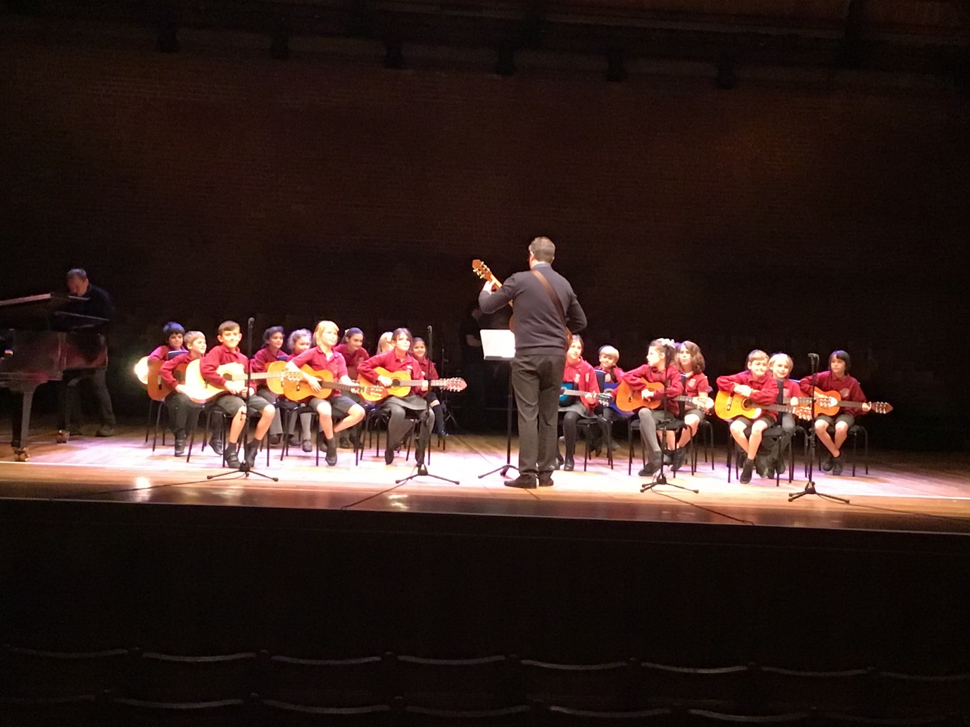
The rehearsal on the main concert stage with Mr Butcher and Mrs Merry.
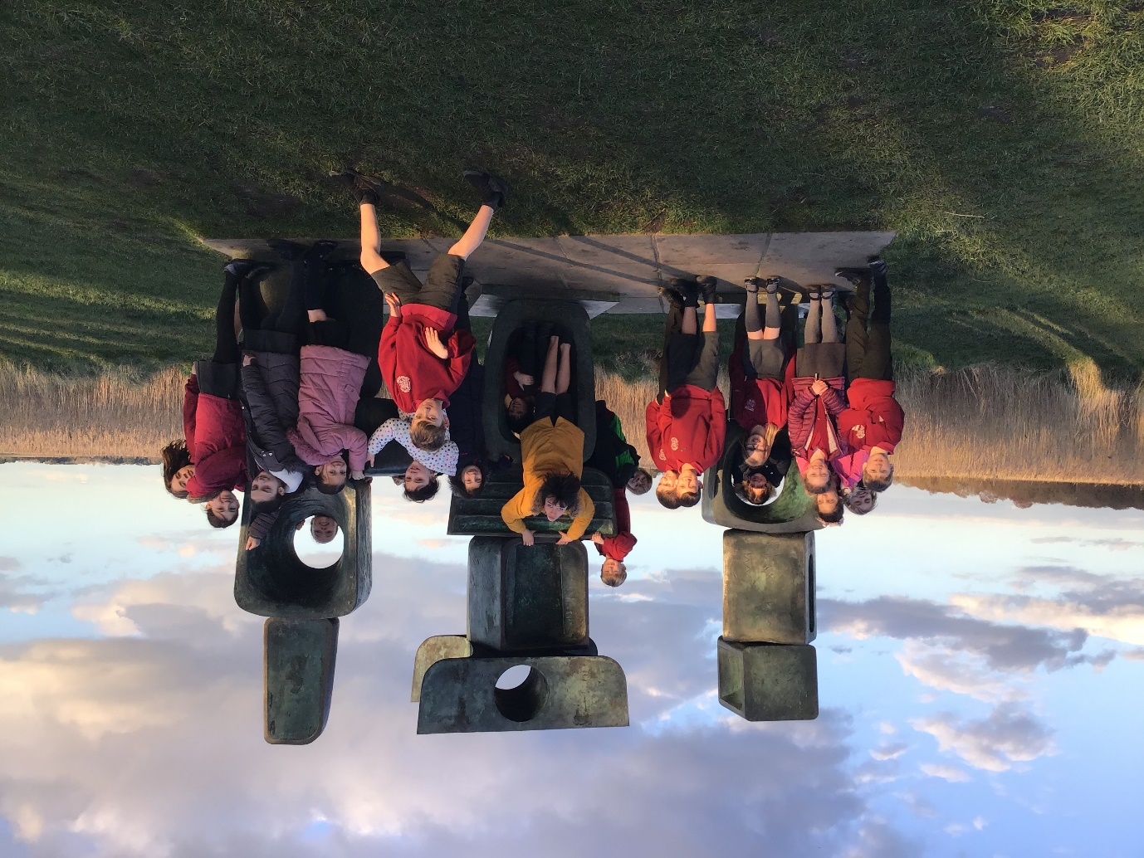
Having fun in the beautiful grounds of Snape Maltings during our time off between rehearsals.

