Buddhism Concepts and Key Questions covered
Key Stage 2
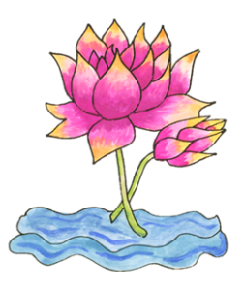  How did Buddha teach his followers to find enlightenment? | 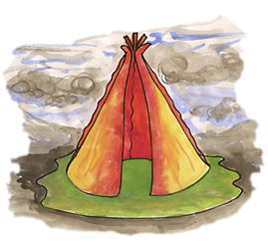  How does the Triple Refuge help Buddhists in their journey through life?

End of phase Buddhism Core knowledge : What do we want pupils to know?
By the end of KS2, pupils learn the story of the Buddha and about his journey to enlightenment including the Four Noble Truths as the essence of Buddhist teaching. Using the correct terminology, pupils are able to explain the key concepts that help Buddhists today on this journey including reference to the Eightfold Path. The role of the Buddhist community is explored as well as the practice of meditation.
Please note: the above will depend on if both Buddhism units are taught in your KS2 scheme of work.

Progression in Buddhism knowledge of text -practice – living
End of KS2
Pupils will be able to:
Text/Narrative | Retell the story of Buddha’s enlightenment.  Explain how and why a Buddhist uses the image of a lotus to explain beliefs about growing towards enlightenment.  Explain Buddhist teachings including reference to the four noble truths.  Show how Buddhists express their belief that the Buddha is a refuge and guide by referring to the story of Angulimala.
Community Practice | Use the right religious words to describe different practices of Buddhists in search of enlightenment on the Eightfold Path.  Describe the Eightfold Path as techniques for overcoming suffering.  Explain how the Buddha’s teachings (dharma) help Buddhists journey along the path.
Living | Describe the use and importance of stillness and meditation.  Evaluate the role of the Buddhist community.  Use the right religious words to describe the practices and experiences of Buddhists belonging to the Sangha, both lay and monastic.  Explain how members of the Sangha support each other at the festival of Wesak.

Understanding the Sequence of the Buddhism units
The requirements of the KS2 Suffolk Locally Agreed Syllabus state that Buddhism as a principal religious community should be encountered in detail for a minimum of one term. Learning about and from Buddhism continues into KS3.

Symbols and Religious Expression | The Journey of Life and Death
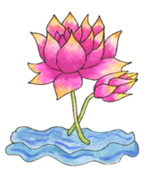  Y5  How did Buddha teach his followers to find enlightenment? | 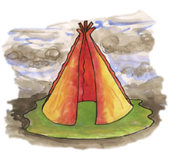  Y6  How does the Triple Refuge help Buddhists in their journey through life?
Enlightenment – Pupils learn about the Buddha and his story. The Four Noble Truths are explored as Buddhist key teaching about life and suffering. The Eightfold path as the means to achieve a release from this suffering. | Refuge- Pupils learn how Buddhists express their belief that the Buddha, his teachings and the Buddhist community are a refuge and guide for release from suffering.

Humanism Concepts and Key Questions covered
Key Stage 2

Why do Humanists say happiness is the goal of life?

End of phase Humanism Core knowledge : What do we want pupils to know?
By the end of KS2, pupils learn what is important to those with non-religious worldviews who call themselves Humanists. They will learn about the importance of reason, respect and the scientific principals which lay behind this worldview. Pupils will have opportunities to encounter thought of famous Humanists past and present. They will ask questions about what the meaning and purpose of life is for a human being and debate whether happiness should be considered a right for all. They will explore and learn about the ceremonies and celebrations of Humanists and what these look like and mean to those who live their life in this way today.

