Hinduism Concepts and Key Questions covered
Key Stage 2
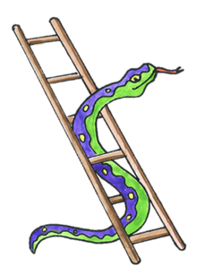  Why do Hindus want to collect good karma? | 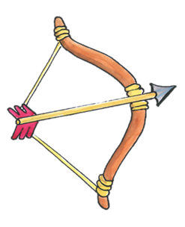  How does the story of Rama and Sita inspire Hindus to follow their dharma? | 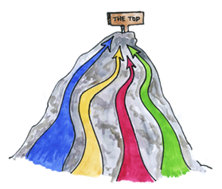What spiritual pathways to Moksha are written about in Hindu scriptures? | 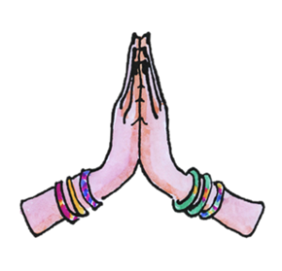How do questions about Brahman and atman influence the way a Hindu lives?

End of phase Hinduism Core knowledge : What do we want pupils to know?
By the end of KS2, pupils learn that Hinduism is a complex tradition which draws on many ancient philosophies. They will encounter some of the traditional stories told to Hindu children and some of the inspirational figures. Pupils will learn some of the key teachings about the Hindu’s Supreme Being Brahman and other deities worshipped. They will learn that Hindus take their religious responsibilities seriously; and that even Hindu children must learn to take responsibility for gathering good karma in an attempt to break the cycle of birth and re-birth.

Progression in Hinduism knowledge of text -practice – living
End of KS2
Pupils will be able to:
Text/Narrative | Begin to describe what Hindus might learn from one of the stories of the Panchatantra about living the right way.  Describe what a Hindu might learn from the story of Rama and Sita.  Understand that some Hindus read from the Gita every day for guidance, comfort and advice.  Explain some key teachings Hindus hold about Brahman / Atman linking these to religious texts.
Community Practice | Explain that Hindus are encouraged to perform acts of selfless kindness.  Describe some things Hindus do to celebrate Rama and Sita’s commitment to duty and describe how Hindus celebrate Diwali.  Attempt to explain why Hindu children are encouraged to ‘Be as Rama’ or ‘as Sita.’  Express the importance role of devotion or those who follow the Bhakti pathway.  Explain the different ways Hindus explain their ideas of God.
Living | Know that even Hindu children must learn to take responsibility for gathering good karma.  Explain how belief in the Hindu God differs from that of monotheistic religions.  List how belief in Brahman affects a Hindu’s diet and their attitude to animals.  Give examples of how Hindus express beliefs and feelings about Krishna.

Understanding the Sequence of the Hinduism units
Teaching these units meets the statutory KS2 requirement of the Suffolk Locally Agreed Syllabus which requires four units on the investigating of Hinduism as a principal religion. These four units match the four learning themes required.
Hinduism and Islam – including at least themes 1 – 4

Religion and the Individual | Inspirational People | Teachings and Authority | Beliefs and Questions
Y3  Why do Hindus want to collect good karma?   | Y4  How does the story of Rama and Sita inspire Hindus to follow their dharma?  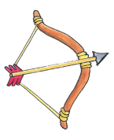 | Y5  What spiritual pathways to Moksha are written about in Hindu scriptures? | Y6  How do questions about Brahman and atman influence the way a Hindu lives?  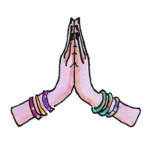
Karma – Pupils encounter Hinduism for the first time. They learn about how the idea of good and bad karma influences Hindus and the importance of selfless kindness. | Dharma – Pupils learn about Rama and Sita and some of the things Hindus do to celebrate their commitment to duty. | Moksha- pupils learn about the different pathways chosen by Hindus to become united with God. This includes learning about the 4 yogas and the importance of devotion for those who follow one particular pathway. | Brahman – pupils delve deeper in to understanding the nature of Brahman, the Hindu God. They explore different deities and understand these show different aspects of the one God.

