Judaism Concepts and Key Questions covered
Key Stage 1 | Mitzvot/ tzedakah  Why is learning to do good deeds so important to Jewish people? | Tefillah/ blessings  Why do Jewish families say so many prayers and blessings? | Teshuvah / G-D  Why do Jewish families talk about repentance at New Year?
Torah / rabbi  Why is the Torah such a joy for the Jewish community? | Key Stage 2 | 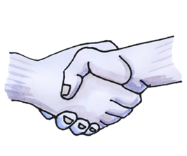What symbols and stories help Jewish people remember their covenant with God? | 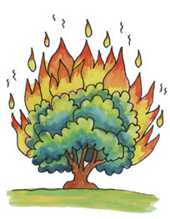What is holiness for Jewish people: a place, a time, an object or something else?

End of phase Judaism Core knowledge: What do we want pupils to know?
By the end of KS1, pupils learn about the importance of the Torah for Jewish people. They encounter some of the stories such as creation, Jonah or Ruth and discuss possible meanings. Importantly they learn Jewish people follow the teachings of the Torah as a rule book for life and learn about how the Torah is remembered and respected. They learn about the importance of Shabbat and the role of other Jewish festivals.

By the end of KS2, pupils learn about some of the Torah stories in more detail, especially the Exodus story and the importance of covenant with God for Jewish people. They extend their learning into philosophical and theological conversation about holiness and describe and compare different Jewish celebrations.
Please note: the above will depend on if both Judaism units are taught in your KS2 scheme of work.

Progression in Judaism knowledge of text -practice – living
 | End of KS1  Pupils will be able to: | End of KS2  Pupils will be able to:
Text/Narrative | Know that Jewish stories contain examples of Good deeds.  Remember all, or parts of, the story of Ruth.  Say at the end of the creation story God rested.  Retell the story of Jonah and begin to talk about its possible meanings.  Remember that the Torah is the most important book for Jewish people given by God. It was written down by a great leader called Moses.  Recall some of the stories of Moses e.g. 10 commandments or his birth | Describe a part of the Exodus story  Describe what Jewish people might learn from the stories of Noah or Abraham about a covenant with God.  Explain what the burning bush story in Exodus teaches about holiness.
Community Practice | Know that Jewish people welcome babies into their community.  Know that Jewish families have a day of rest every week.  That at the start of Shabbat, a special meal, candles are lit and blessings said.  Describe that for Jewish people new year is about saying sorry and making changes.  Say that the Torah is kept in a synagogue or in a special ark.  Know the Torah contains rules. | Describe some different customs and practices Jewish people have as part of their Pesach (Passover) celebrations.  Explain in what way Shabbat is holy and how Jewish families mark its beginning and ending.
Living | Know that Jewish people care for their world.  Describe what some Jewish people wear when they pray.  Describe what happens in a synagogue at Yom Kippur.  Remember that a mezuzah contains important words for Jewish people (the Shema).  Demonstrate how a mezuzah is used by Jewish people. | Explain what happens at Shavuot.  Give examples of what the Torah says about living a holy life.
Understanding the Sequence of the Jewish units
Teaching these units meets the statutory KS2 requirement to revisit Judaism as a principal religion.
Teaching these four units meets the statutory KS1 requirement of the Suffolk Locally Agreed Syllabus.

Belonging | Prayer and Worship | Believing | Leaders and Teachers | Symbols and Relgious Expression | Worship, Pilgrimage and Sacred Places
Y1  Mitzvot/ tzedakah  Why is learning to do good deeds so important to Jewish people? | Y1  Tefillah/ blessings  Why do Jewish families say so many prayers and blessings? | Y2  Teshuvah / G-D  Why do Jewish families talk about repentance at New Year? | Y2  Torah / rabbi  Why is the Torah such a joy for the Jewish community? | Y3  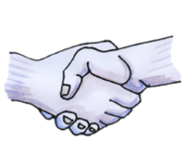What symbols and stories help Jewish people remember their covenant with God? | Y5  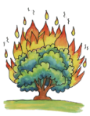What is holiness for Jewish people: a place, a time, an object or something else?
Mitzvot – introduces Jewish faith and good deeds and helping others. Allows comparison with the previous Christianity unit on welcoming babies. | Teffilah – pupils learn about prayer and worship and the importance of rest in the Jewish faith through listening to the creation story. | Teshuvah – Pupils encounter more Jewish stories and learn about the importance of saying sorry for Jewish people. Can be compared to previous Christianity prayer and worship unit. | Torah – pupils learn about this special book, where it is kept and how it remembered and respected. | Covenant – Pupils explore in greater depth the Exodus story and stories which demonstrate a covenant with God. | Holiness - Pupils parktake in activities aimed to deepen their understanding of the Jewish tradition and the stories in the Torah by viewing them in light of teaching about God’s holiness.

